Perform information architecture analysis and design a web service. Research, evaluate and compare web frameworks. Implement the selected framework and emerging technology into the web service. Test and assess the implementation.

WEB701 Report

Web Technologies

13/11/2024

Jayden Houghton – 13524050

Contents

Design (Milestone 1) 2

Project Brief 2

Requirement Analysis 3

Site Goals 3

User Experience 3

Site Content 12

Site Structure 13

User Stories 32

Project Management 32

CRUD Analysis 35

API Prototype 36

Evaluation (Milestone 2) 39

Purpose of Web Frameworks 39

Emerging Technology 40

Selected Technology 40

Implementation Investigation 40

Impact on Internet Users 41

Evaluation and Comparison 42

Account System 43

Token Transaction 59

Data Retrieval 67

Framework Recommendation 71

Development (Milestone 3) 72

Functional Implementation 72

Authentication & Administration 72

Product Registration & Tokens 75

Interactive Elements 77

Token Transactions 79

Server-Side Database 83

Emerging Technology 85

Research & Libraries 85

Implementation & testing 86

Links 88

References 89

# Design (Milestone 1)

## Project Brief

The Re:Tech charity is a technology supply charity in the Nelson region who offer refurbished and second-hand technology (phones, computers, tablets, chargers, headphones, etc.) to the local community. This provides many benefits, including helping those in need to stay connected with friends and family, and providing devices for children to use in schools.

A website is required for the Nelson region for members of the community to be able to donate devices and for members of the charity to manage and distribute the tech to those in need.

The purpose of the new website is to help with the distribution of the service or product by members of the charity to customers. Like a “food bank”, the website lets members register and describe the service or products they are providing, the number and frequency of the offerings.

The website lets members of the community (beneficiaries) access the service, by providing tokens that can be “spent” to gain technology devices and equipment. To achieve the charity’s goal, the website will have an online token function on the website that lets a beneficiary access a limited number of tokens, for example the system needs a mechanism that verifies that a member of the community is accessing the service and that the token belongs to a particular community member. The website needs some homepage text about general information about the technology offered, how it works and who can sign up.

The following features are required on the website:

1. Charity members and beneficiaries can register, log in and administer their own accounts. Members use the website to register their products and services, and beneficiaries use the system to acquire tokens.
2. Interactive element(s) that engages the website user.
3. The system provides an interface that the members can use to accept a token in a transaction.

## Requirement Analysis

### Site Goals

#### Mission

The purpose of this webapp is to provide a place where those in need can acquire technology to improve their wellbeing, education, and community connectedness. The app will allow anyone in need from the Nelson/Tasman region to register and receive tokens, which can be traded for technology of their need (phones, headphones, computers, chargers, modems, etc.). The goal of this service is to help give everyone the opportunity to education, upskilling, communication, and connectivity to friends and family.

#### Goals

Short-term: give access to technology for education and learning to children in poverty as well as devices to connect friends and families living apart.

Long-term: a more educated, connected and capable community.

#### Intended Audiences

The intended audience of this webapp are people living in the Nelson/Tasman region in a poverty situation, who cannot afford to obtain fundamental technology.

#### Visiting Reasons

1. As someone in need looking for services to assist them
2. As a benefactor of the charity to collect tokens and make a purchase
3. As a donator to donate equipment or other support

### User Experience

The webapp should be simple and intuitive to use on any device, making it accessible to anyone in need.

#### Audience

1. Children from a family living in poverty:
   1. Require computers for school
   2. Phones for communicating with parents and friends
2. Adults living in poverty:
   1. Phones for communication with friends, family and relatives
   2. Device for important emails and banking (rent, bills)
   3. Device for online upskilling or tertiary education
   4. Wi-Fi access and modem for internet at home
3. Donators
   1. Donate devices and equipment
4. Charity members (admins)
   1. Manage members
   2. Upload and manage items

#### Scenarios

**Sue Wilson** – *age* *32, female, 2 kids, no partner, restaurant waiter*

Sue works as many shifts as she can and receives a benefit to cover her expenses and look after her kids, but she barely earns enough to get by. Her brother lives in Palmerston North and was recently diagnosed with cancer. Since her last phone broke, she can only communicate with her family and check emails by visiting the library which has public Wi-Fi. She lives pay check to pay check, so purchasing a phone would take a big cut out of the money she needs to support her family. She wants to be able to communicate with her family quickly and easily so she can stay updated and be able to support them. Through Re:Tech, she has been able to acquire a new phone, allowing her to communicate and video call frequently with her family, helping them stay connected.

Persona: adults living in poverty requiring a hone for communicating with family.

**Elias Walker** – *age 13, male, student*

Elias studies at Nelson College and is in year 10. He has a passion for coding and IT. He had been using his mum’s old laptop for his schoolwork, however it was 10 years old and recently stopped working. His family don’t earn enough to be able to afford a new laptop, so he has had to use school computers in the library to do any homework as he no longer has access to a computer at home. This puts huge limitations on him being able to learn and explore his passion of coding. His family signed up to Re:Tech and used their combined tokens to purchase a new laptop for him. He has been excelling in his schoolwork and now spends most of his spare time building programmes and developing his coding skills.

Persona: child in an impoverished family requiring a computer for school and passions.

**Steve Anderson** – *age 27, male, unemployed*

Steve has a physical disability which has made it hard to find a job. He has had a few jobs over the last few years, but they are low paying jobs and haven’t lasted long. He has been registered with Re:Tech for a few years now, and has purchased items using the token system in the past. He uses his phone frequently to apply for jobs and keep up with current job applications. His phone charger stopped working, cutting off the important ability to job hunt via his phone. Using Re:Tech, he purchased a new phone charger which has allowed him to continue his job hunt and recently successfully start his new job as an administrative assistant at a local business.

Persona: unemployed young adult with a physical disability.

#### Competitive Analysis

**Recycle A Device (RAD)**

RAD is a New Zealand initiative that refurbishes and redistributes technology to those in need, aiming to bridge the digital divide for students, families and communities by donating technology to who may otherwise not be able to afford it. In the process, youth are also taught how to refurbish technology (Recycle A Device, n.d.).

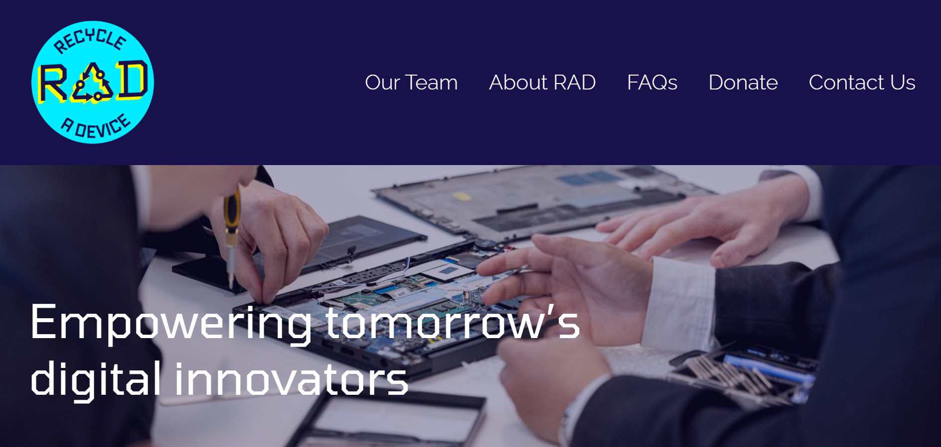

RAD has a clean and simple homepage which allows for easy navigation. The navbar proportions are off (too large), but otherwise it is a good design. This allows for quick and simple navigation across the website. Their homepage includes a number of relevant photos and videos of the charity, as well as text explaining their mission and the benefits offered. This makes it clear and visually interesting to understand what they are and how they operate. The homepage also includes links to easily find key information on the website, including donation links. This helps to direct users to these pages and makes navigation easier.



They have also included separate pages for donating money or devices. For devices, a built-in form collects contact data and details, however for money, an external form is used to handle payment. This would have been done to handle transferring money in an easier and more secure way. As our charity can accept devices or money, it would be beneficial to use a similar setup. They also have a contact form with other methods of contact.

The rest of their website is laid out in a similar fashion: clear, simpler, modern and easy to use. This means that anyone coming to the website can easily find what they want and are more likely to interact with the charity by donating or using the service.

The only significant area missing is how to become a beneficiary of the charity. With a cursory glance of the website, there is no information on how to receive one of their refurbished laptops. While they do distribute devices through partnered schools and community organisations, the website would benefit from making this clearer. Overall, this is a very good demonstration of a charity website.

**RE:MOBILE**

RE:MOBILE is a New Zealand non-profit mobile phone refurbishing and recycling scheme accredited by the Ministry for the Environment. Refurbished phones are sold to business specialising in the re-sale of second-hand phones in overseas markets. Over 95% of the materials in recycled phones are recovered (RE:MOBILE, n.d.)

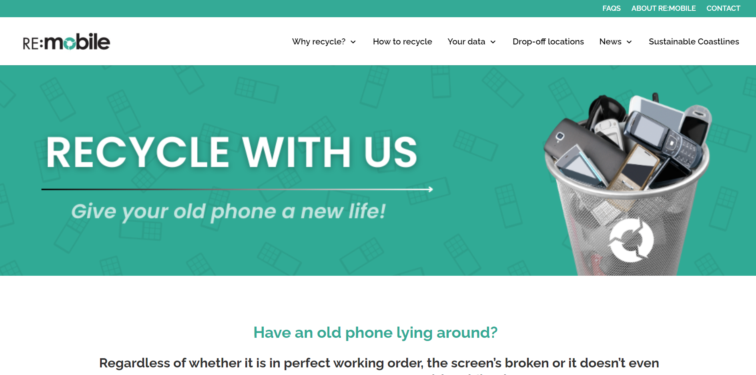

RE:MOBILE also has a simple, clear design which helps for easily navigation.

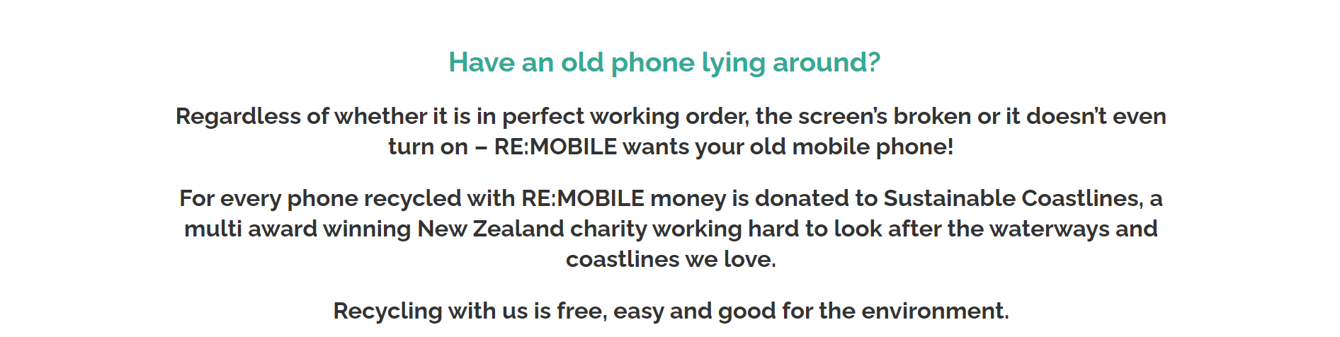

The website states the charity’s mission and purpose with a call to action. This makes the scheme’s purpose immediately obvious to users and motivates them to use it. The website is full of information and statistics explaining the benefits of recycling and refurbishing phones, as well as how the process works.

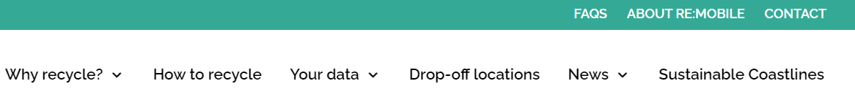

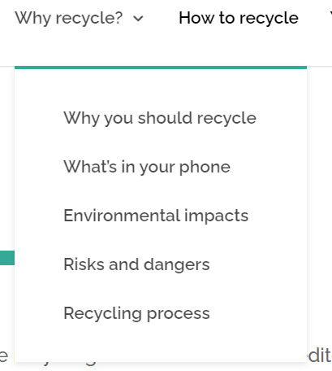I personally think that the double nav bar is confusing and unnecessary.

I also think that there is too much information for the average user, and it is spread out across too many pages. While it is definitely beneficial to include statistics and explanations of the benefits, the average user will likely not read most of this information. By condensing the key points into fewer pages, more users would spend the time to learn and understand the benefits. It would also make navigation to the specific information the user wants a lot easier, improving the usability of the website. Our website will be a lot less focussed on the environmental impacts and risks, so there will be a lot less information to display, meaning this shouldn’t be an issue.

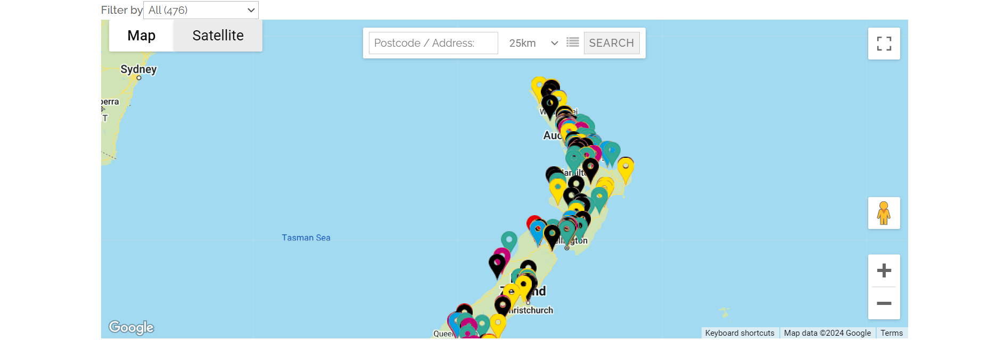

Their website also includes a map with search and filter functionality. As they have many drop of locations, this is a very useful feature for users to work out where to go. This likely won’t be useful for our charity as they are just based in Nelson, unless they expand significantly, however a simple map would be useful.

**TechCharities**

TechCharities is a United States non-profit organisation that refurbishes computers and distributes them to families and students in need. Their goal is to improve quality of life for those in-need (TechCharities, n.d.).

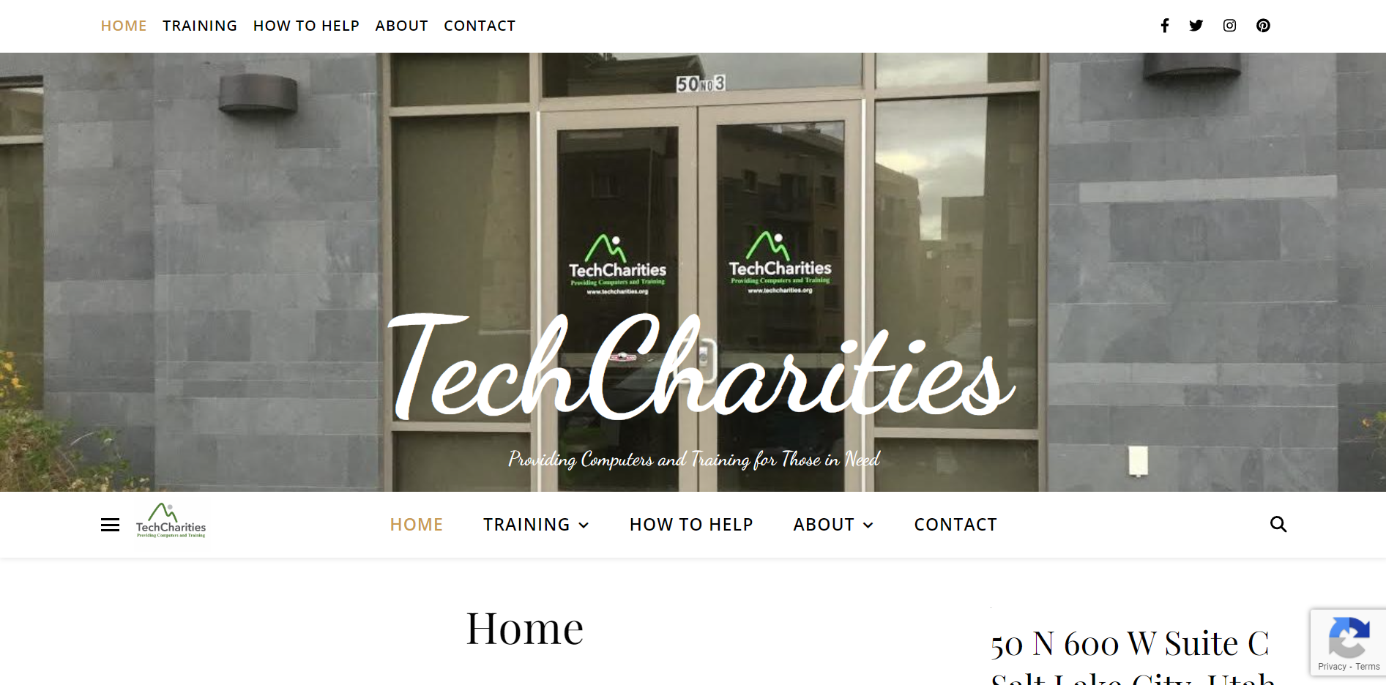

Like the other websites, they have a fairly simple and clean design that improves navigation and usability. The sticky nav bar is a useful addition, however the double it shows at the top of the page may be confusing for some users. Otherwise, the nav provides clear links to key pages on the website.

The mission and purpose are fairly clearly stated at the start of the home page, however the donation and beneficiary links are pushed down the page by the layout. These should be higher up the page to be easier to find.

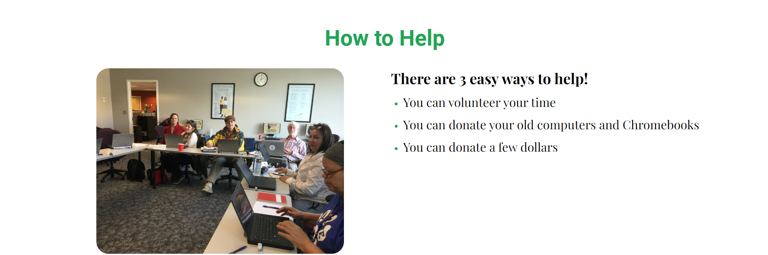

Their how to help section is very clear, making it as simple as possible for donators to help, likely increasing the amount of support they receive. The use of photos builds credibility and builds an emotional connection, motivating users to become involved with the charity. To get to a download think however, users must navigate from the homepage to the ‘How to help’ page then to a donation form, which requires more clicks.

Their donation forms and links however are less simple. They use two different forms for device donation, a Venmo link for money donations and a general contact form. Device contact forms include contact details, estimated device quantity, donation frequency, data security options, documentation requests, delivery options and a message. This allows the charity to gather a lot more information than many other charities do. Contact details, quantity and frequency will all be very important details for our forms to collect. Any devices collected by the charity will be reset and all data wiped, so we should not need this section of the form. While the charity may collect some success stories, they will likely not offer reports or testimonials for donating parties like TechCharities does, so this section won’t be necessary either. Both donation forms are identical but for different end use of the donated devices. This seems like an unnecessary duplication and could be solved by adding a single dropdown to pick what cause the devices are for, however this won’t be an issue on our website.

**World Computer Exchange (WCE)**

WCE is an international charity with the goal of reducing the digital divide for youth in developing counties. International volunteers refurbish computers that are donated to schools and community organisations in developing countries. The charity also provides digital training and coding bootcamps (World Computer Exchange, n.d.).

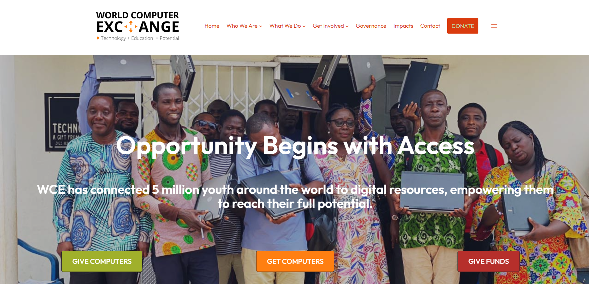

WCE has a very good home page:

* Clear nav bar to navigate to key pages
* Concisely shows their purpose and global benefit already achieved
* Immediately displays links for donors and beneficiaries to direct users
* Donation link in nav bar for easy access and quick navigation
* Lists featured impacts showing other benefits and stories immediately after the top banner
* Lists community support and quotes for credibility
* Home page includes links to other sections of the site (who we are, what we do, etc.) to help the user easily find the information they want

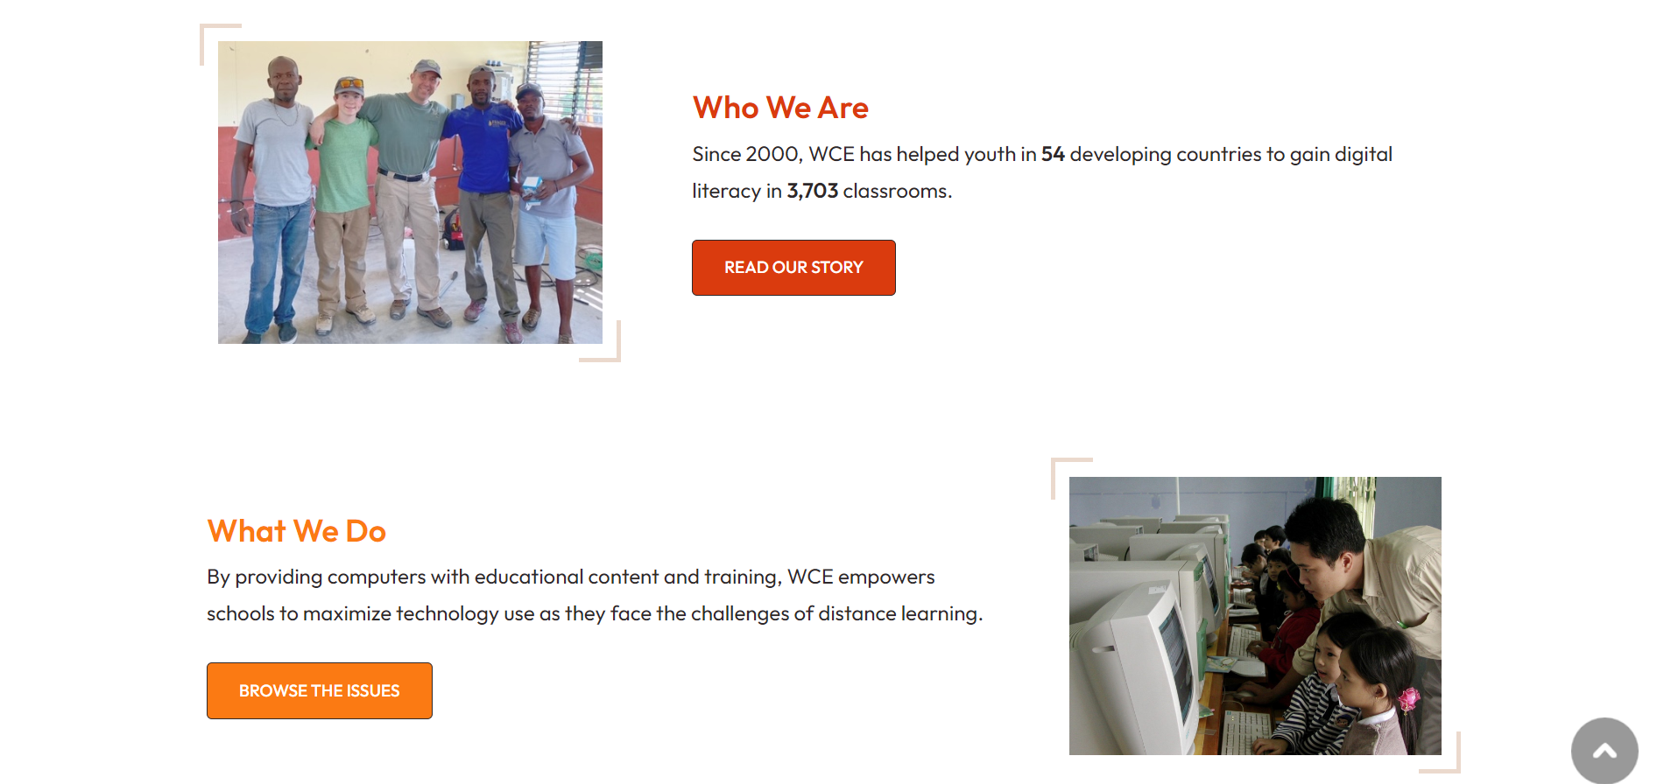



Information is displayed in highly readable and organised methods, improving the usability of the website. The website includes plenty of information about how the charity works, success stories and the benefits they have produced, but doesn’t overload the user with too much text or details. This is a very well designed website. Plenty of links on the homepage help direct users through the website and to the information they want.

WCE offers a large variety of donation methods. For fund donations, they accept PayPal, check or credit card. ReTech will not accept checks but will have some form of online payment. WCE also accepts device donations by drop-off, mail-in or business collection. ReTech will only support drop-off for the safety of the devices and as they only operate locally. Each form requires contact details, donation description and an address.

For requesting computers, WCE does not use a form on the website or a shop system, but downloadable Word document forms.

**Digital Wings**

Digital Wings is a New Zealand charity that provides IT equipment and support to charities and community organisations. Their goal is to support other organisations in promoting digital technologies to those digitally disadvantaged or underserved (Ditgital Wings, n.d.).

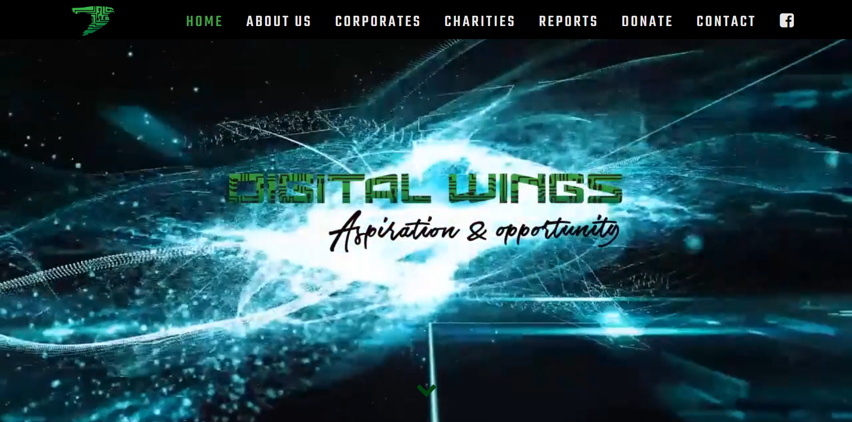

Digital Wings has a looping complex animation on the home screen, which makes it overly busy and overwhelming. The background image combined with font choices makes some sections of the website difficult to read, posing an accessibility concern. They provide statistics on the charity and links to success stories on the homepage, making it easy for users to find these sections. Their purpose and goals are clearly laid out helping user’s understand the charity easily, however the theme of the rest of the website is very different to the homepage.

Information is presented via methods that are more difficult to read and make finding information more difficult, such as the scrolling list of charities. Donation information is limited, which may dissuade some users from donating. The website overall feels busy and slightly disorganised, making it more difficult to use.

Their home page includes links to other pages, which helps direct users to these sections. Digital Wings has implemented a number of slideshows across their website. This is a good way to show more statistics and images such as location maps which the user can interact with. Donations are processed by a partner business, so the donation link takes you to a 3rd party site.

**Summary**

Features of a good charity website:

* Clear nav bar for easy navigation across key pages
* A few images to build credibility, demonstrate the charities work and make the website more visually interesting – sideshows are good for lots of images
* Display statistics of how the charity has helped
* Diagrams and infographics help communicate information quickly and in an interesting format
* Donation and beneficiary links should be near the top of the home page and ideally in nav bar
* Clearly display the charity’s mission and purpose at the top of the home page
* Include information about the charity (who they are, what they do, how it works, etc.) in a concise format
* Clear information on how to donate or receive the charity’s service
* Contact form + contact details (email, social media)
* Use a secure 3rd party service for financial donations
* Multiple options for financial donations means it is easier for users to donate
* Donation form should include contact details, device quantity, frequency, and a message/description
* Built in forms are easier than downloadable documents

### Site Content

**Content**

* Navigation bar between main pages
* Statistics of charity benefits
* Statistics of people in need with technology
* Charity mission/purpose
* Donation link
* Sign up form
* Login form
* Images of charity service
* Success stories with images
* About the charity
* What the charity does
* How the charity works
* Receive tokens
* View tokens
* Account details
* Shop
* Purchase confirmation
* Member list and controls
* Upload items

**Functional Requirements**

* Login to an existing account
* Register new accounts as beneficiary or charity member
* Members can donate items
* Beneficiaries receive tokens on a semi-regular basis (tbc)
* Beneficiaries can purchase items from the shop with their tokens
* Users can update account details
* Users can delete their account
* Responsive design for mobile and PC

**Grouping**

Using the content and functional requirement lists, I worked through the process of grouping related items together to begin forming the website structure of pages. I want the website to be easy to navigate and for content to be laid out in a logical manner, so it is important that content is grouped appropriately. The final list can be found under Site Structure List.

### Site Structure

#### Metaphors

**Organisational**

The about page of the website will reflect the organisational structure of the charity. This page will talk about the Board of Trustees, the different sections of the charity (e.g. management, shop volunteers), partner organisations, and ‘shopfront’ locations.

**Functional**

The shop section of the webapp is modelled and inspired by physical shops. Items are laid out on the screen like they may be in a shop window or on shelves, so users can browse what items are available. Clicking on an item to view more details is like stopping to pick up and item and read the packaging. There will also be a cart system and checkout page, which is a digitalised version of a physical cart to store items and the checkout process when leaving a store.

**Visual**

The theme and design of the website will be inspired by computers. The website will be laid out in a logical and organised fashion like items on a computer (e.g. files in a folder). It will use a sleek and modern theme like new laptop designs, utilising clean, easy-to-read fonts and a simple monochromatic/muted design.

#### Site Organisation

**Site Structure List**

* HOME PAGE
  + Charity mission/purpose
  + Images of charity service
  + Donation link
  + Become a benefactor link
  + Success stories with images
  + Statistics of charity benefits
  + Statistics of people in need with technology
* ABOUT PAGE
  + What the charity does
  + How the charity works
  + Goal/purpose
  + Charity leaders and team
  + Images of charity service
* LOGIN PAGE
  + Login form
  + Link to register form
* REGISTER PAGE
  + Sign up form
  + Link to login form
* CONTACT PAGE
  + Contact form
  + Contact details
  + Social media links
  + Address and map
* BENEFICIARY ACCOUNT PAGE
  + View tokens (automatically receive)
  + Purchase history
  + View items to be collected
  + Account details (includes updating and deleting account)
  + Logout
* SHOP PAGE
  + View items available (item name, token cost, details, quantity)
  + Purchase items
* ITEM PAGES
  + View item’s name, token cost, details, quantity available
  + Add to cart
  + Delete or update (admin/staff only)
* DONATOR ACCOUNT PAGE
  + Account details (includes updating and deleting account)
  + Donation form
  + Logout
* STAFF ACCOUNT PAGE
  + Account details (includes updating and deleting account)
  + Upload items to shop
* ADMIN ACCOUNT PAGE
  + Account details (includes updating and deleting account)
  + Upload items to shop
  + View and manage all account
  + Create new staff/admin account

**Architectural Blueprint**

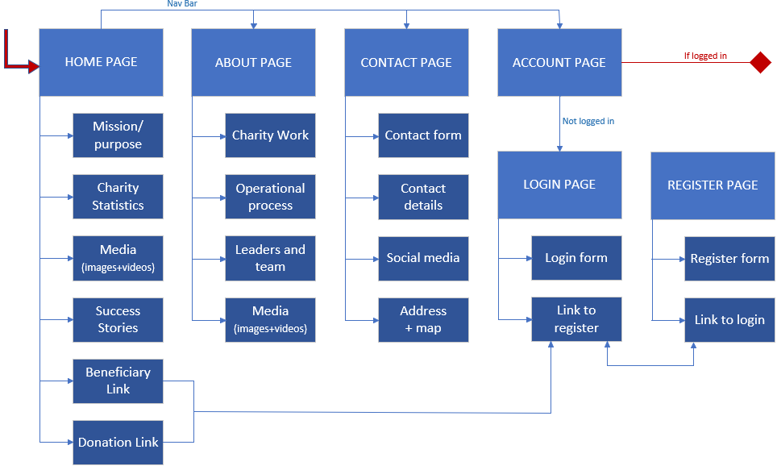

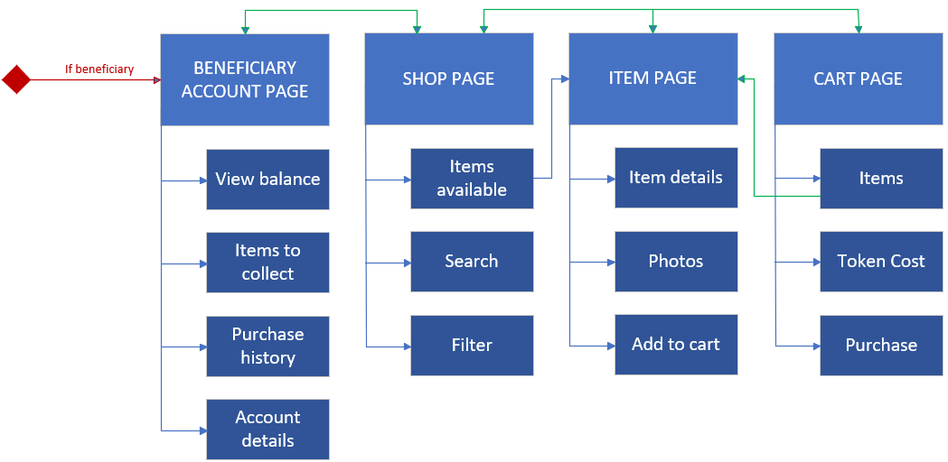

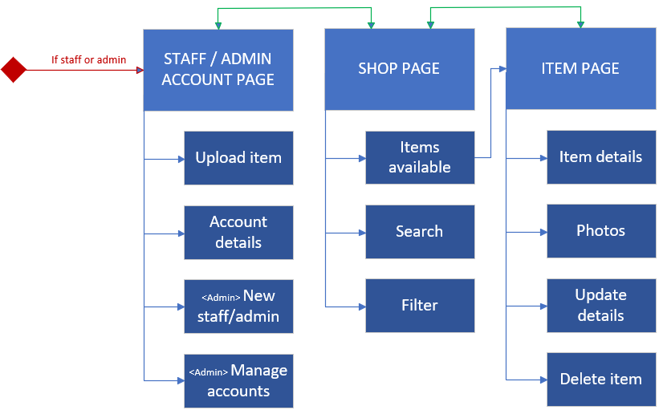

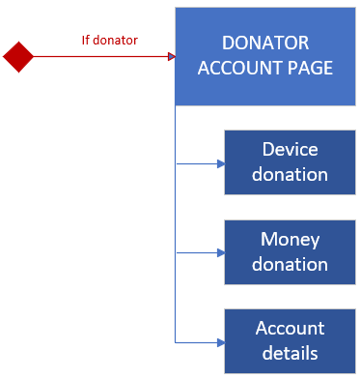

#### Visual Design

**Home Page**

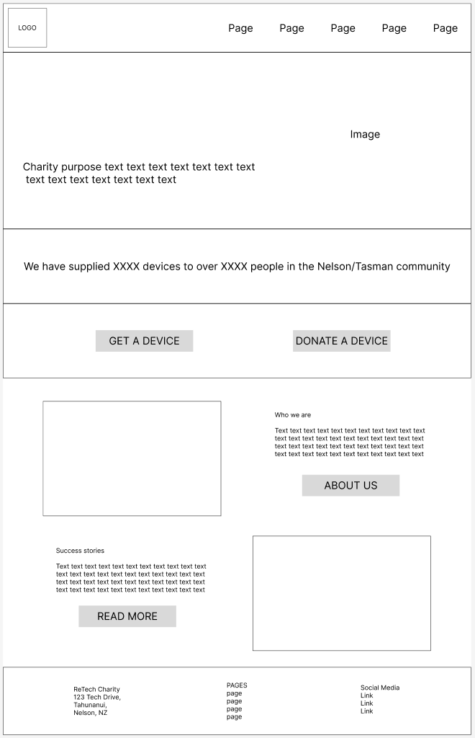

**About Page**

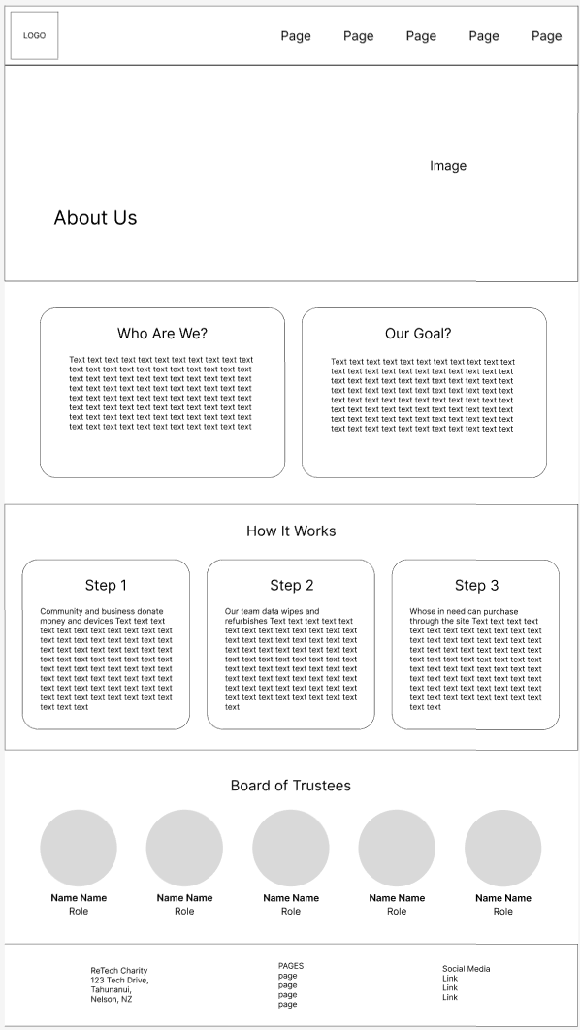

**Contact Page**

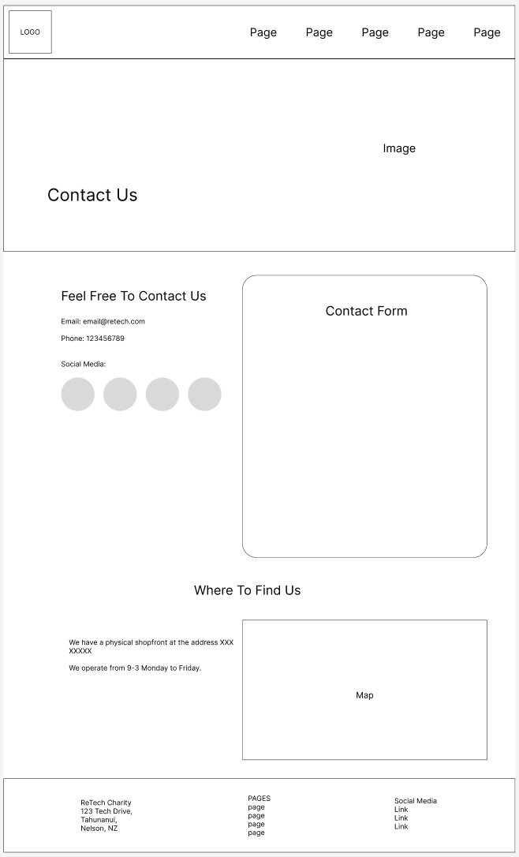

**Login Page**

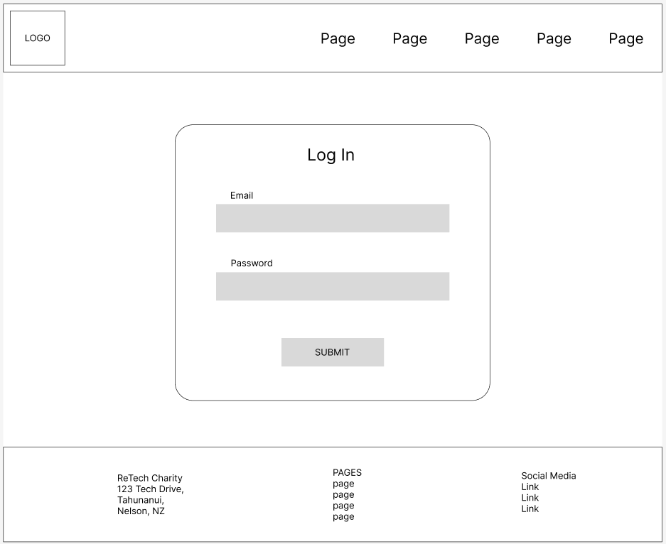

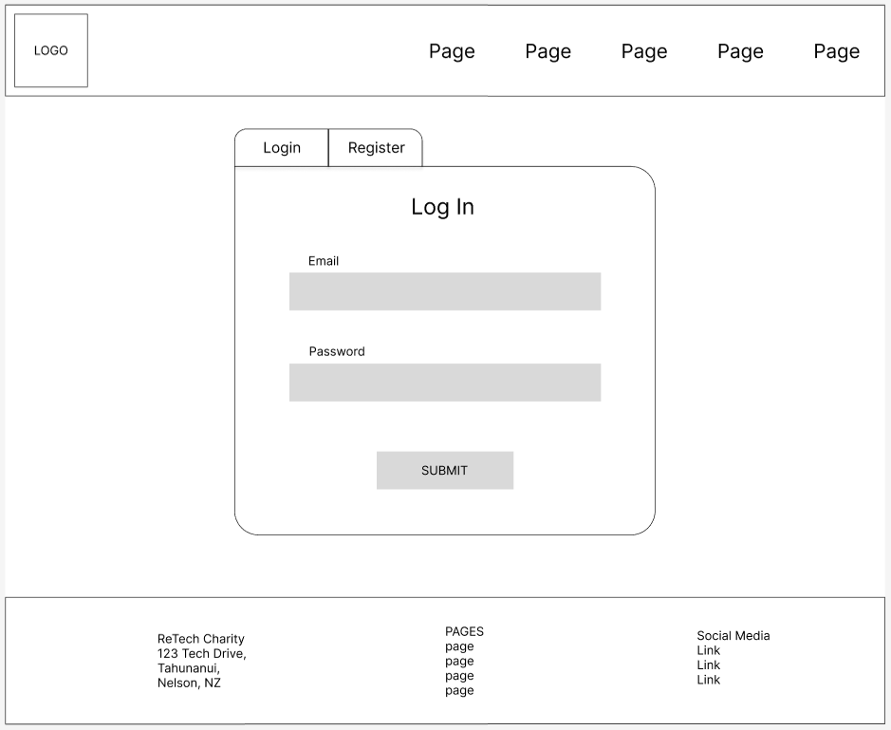

**Register Page**

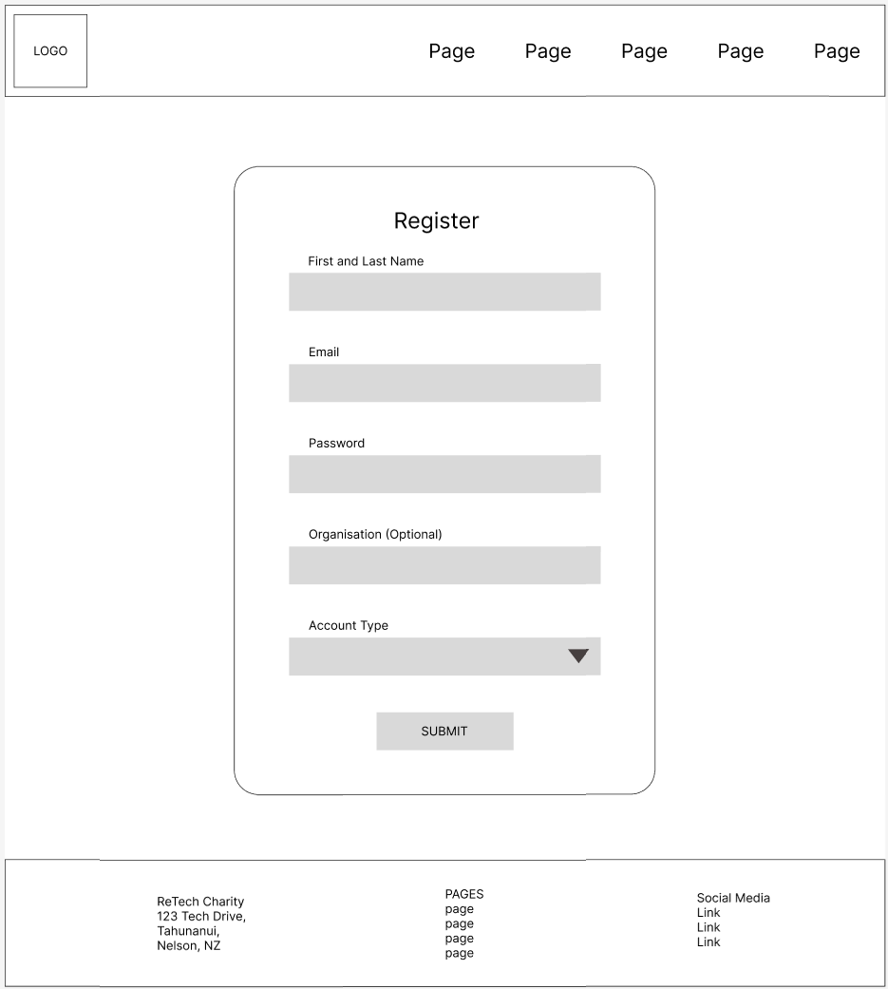

**Donator Account Page**

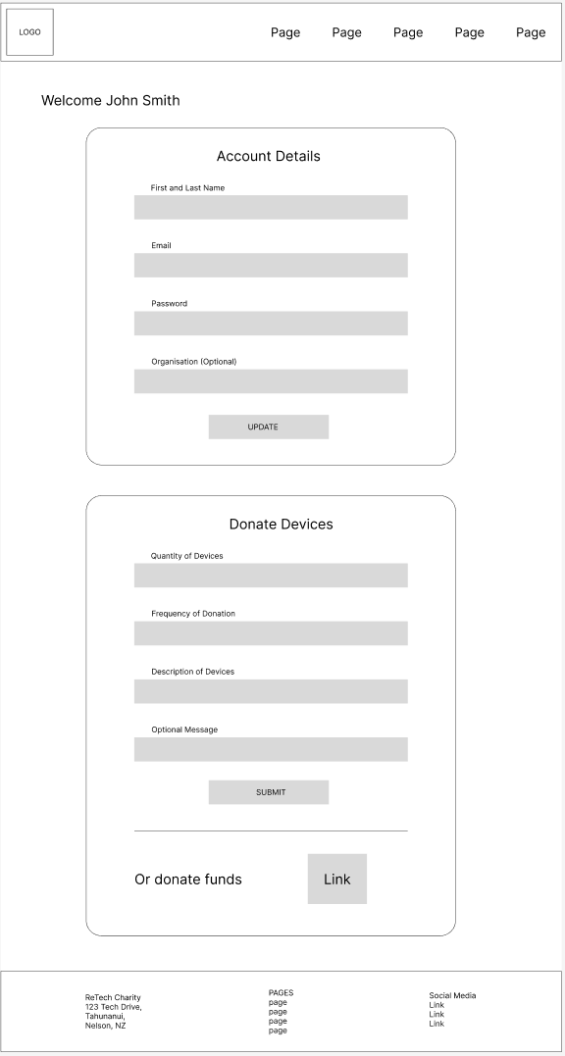

**Beneficiary Account Page**

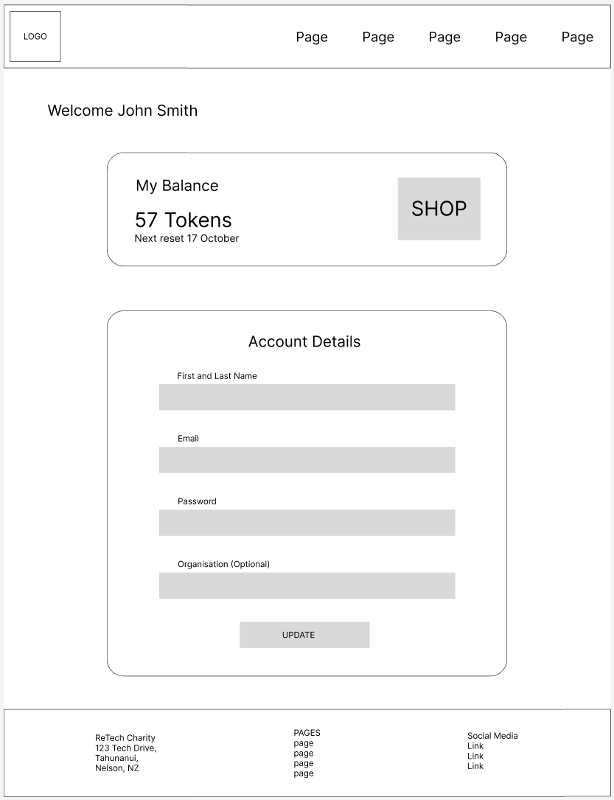

**Shop Page**

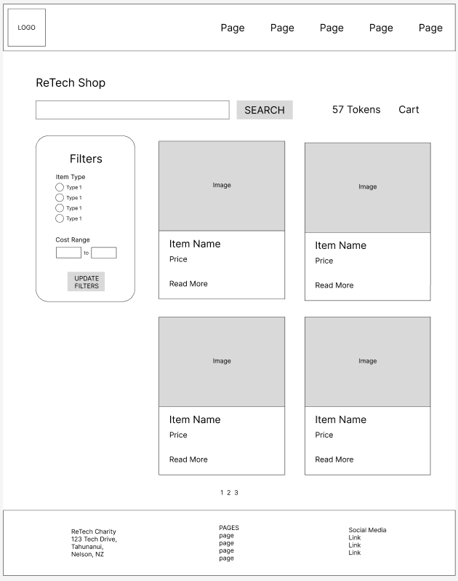

**Item Page**

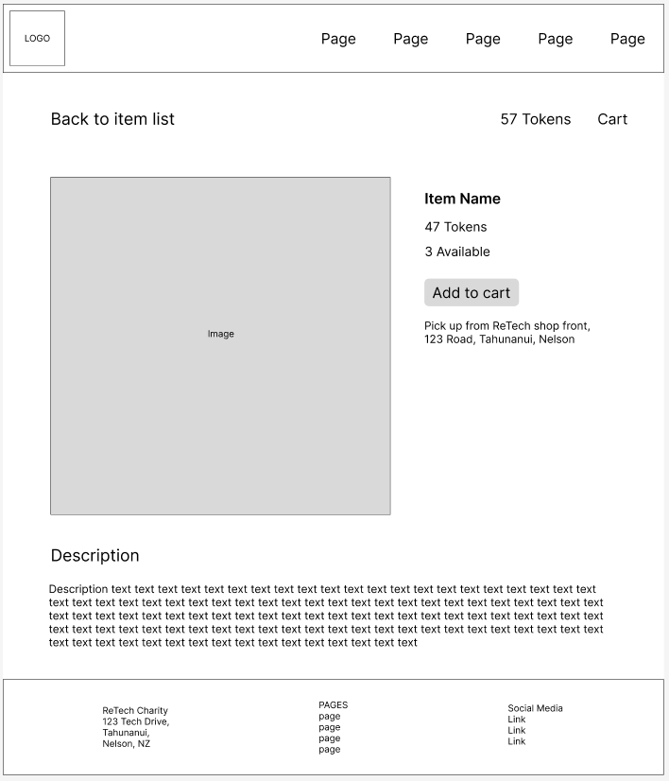

**Cart Page**

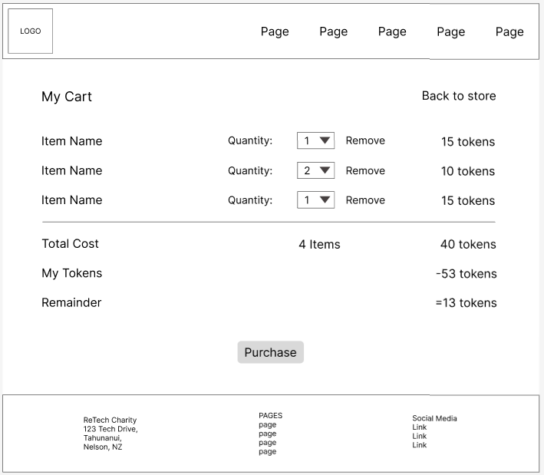

**Staff/Admin Page**

Staff and admin are the same except the accounts option is only for admins.

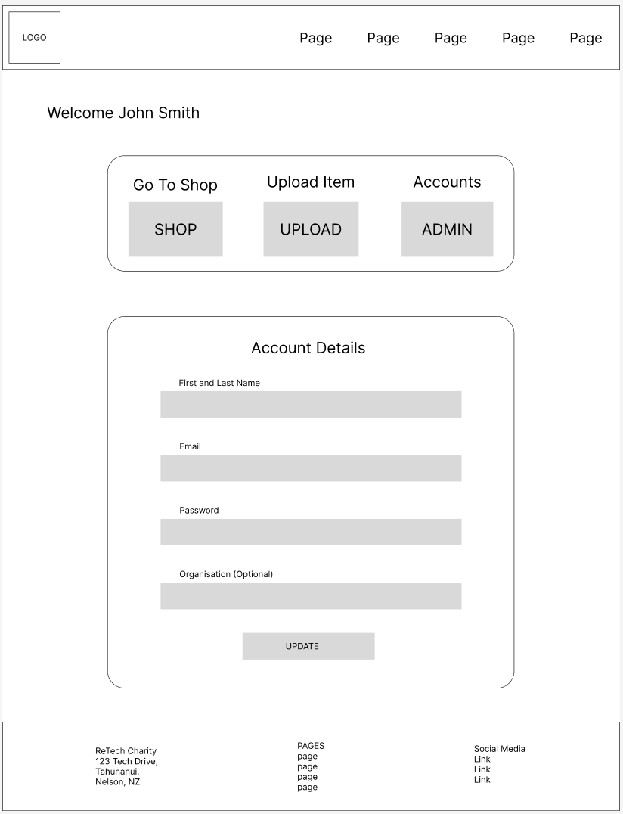

**Upload Item Page**

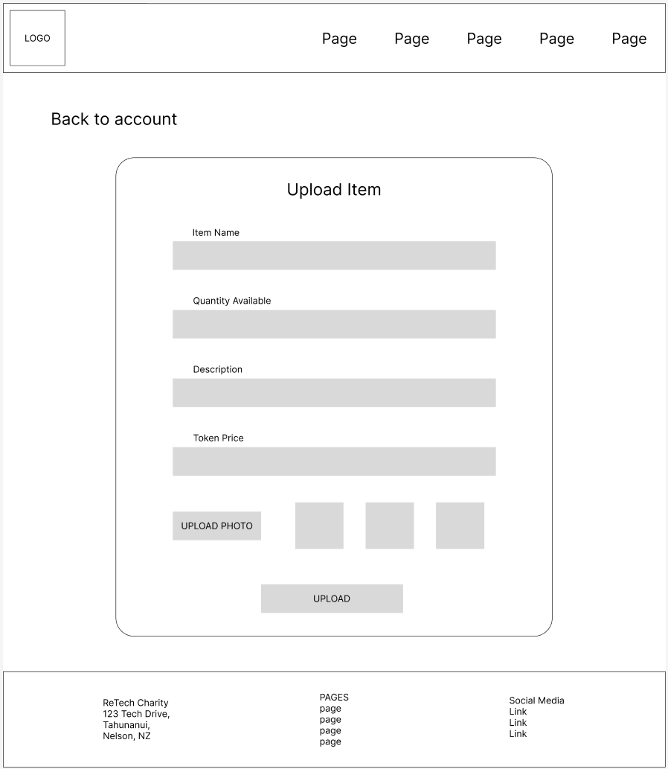

Admin Page

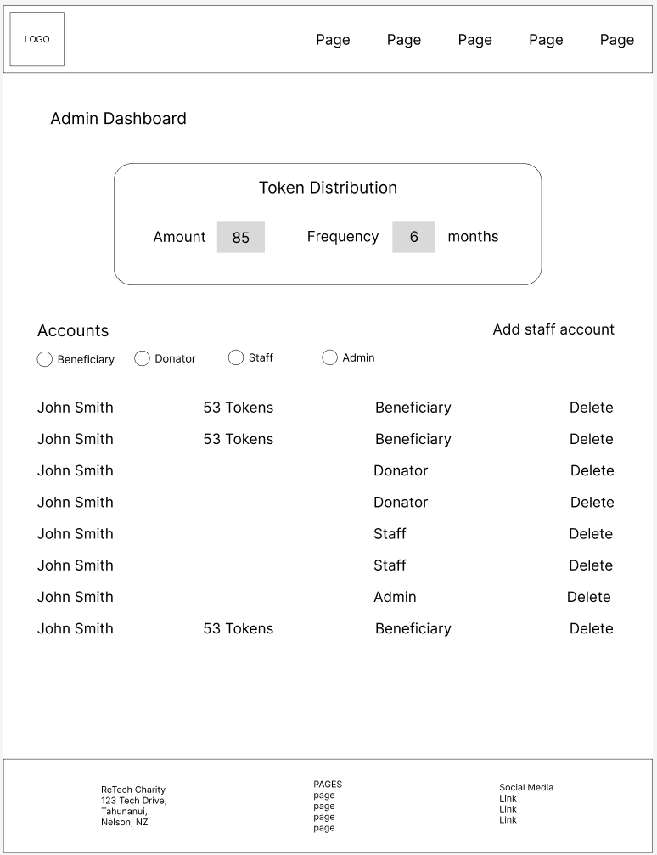

**Colour Mockup**

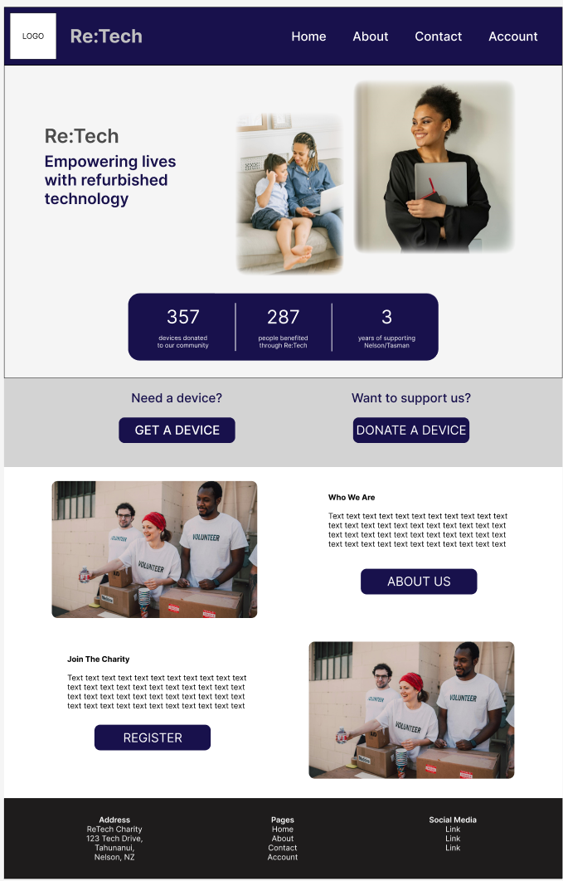

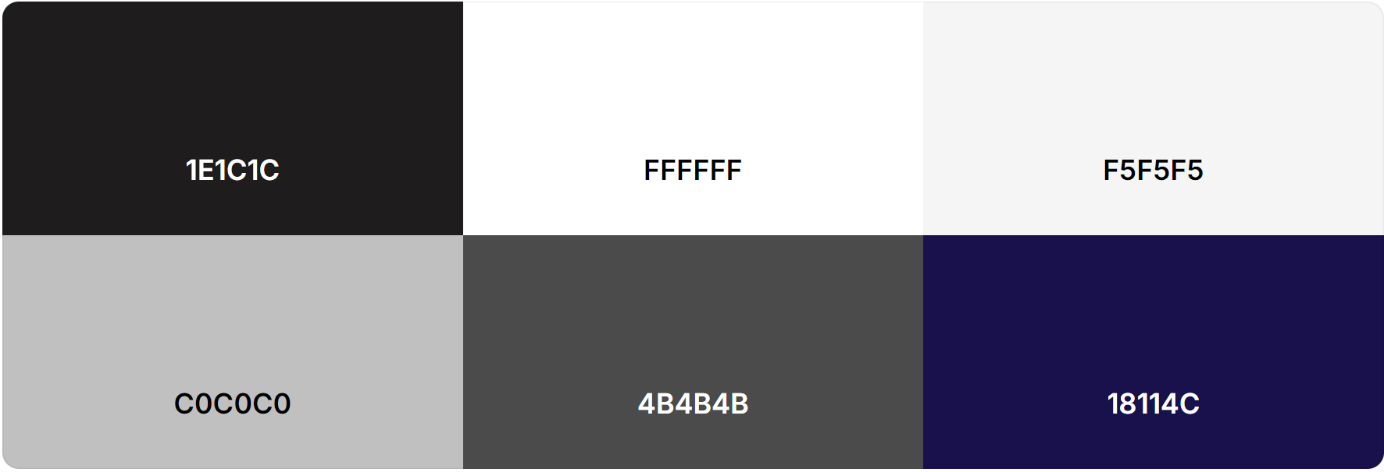

## User Stories

### Project Management

#### User Stories and Requirements

1. As a donator, I want to donate devices to support people in need.
   * Register/login
   * Device donation
2. As a donator, I want to donate money to support people in need.
   * Money donation
3. As a donator, I want to have administration power over my account to be in control of my data.
   * Account page (update data)
   * Delete account
4. As a potential donator, I want to learn about the charity to decide if I want to support it.
   * Home page
   * About page
5. As a potential donator, I want to get in contact with charity staff to get additional questions answered.
   * Contact page (contact form)
   * Social media links
6. As a beneficiary, I want to be able to easily view all available items with their details to be able to find what I need.
   * Search, filters
   * Shop page and item pages
   * Cart + purchase
7. As a beneficiary, I want to be able to view my tokens, so I know how much I have to spend.
   * Account page (tokens view)
8. As a beneficiary, I want to be able to see how I have used my tokens so I can track how I have used the charity’s service.
   * Purchase history
9. As a beneficiary, I want to have administration power over my account to be in control of my data.
   * Account page (update info and delete account)
10. As a beneficiary, I want to pick up the items I have purchased with my tokens to use those devices to improve my situation.
    * Items to collect list (account page)
    * Map and address (contact page)
11. As a potential beneficiary, I want to know how the charity can help me to know if I should register.
    * Home page
    * About page
12. As a staff member, I want to be able to upload new items so there are always items available for beneficiaries to purchase.
    * Upload page
13. As a staff member, I want to be able to manage items on the shop so that the items in the shop reflect the items available.
    * Update item page
    * Delete item
14. As an admin, I want to be able to manage accounts so we can manage and moderate our users.
    * User list
    * Delete account
15. As an admin, I want to be able to create new admin and staff accounts so that we can easily expand our team.
    * Create admin/staff account page
16. As an admin, I want to be able to manage when and how tokens are given to beneficiaries so we can update this to reflect our supplies.
    * Token settings (quantity, renew frequency)

#### Backlog

I have implemented a simple scrum hierarchy in DevOps to represent the different user stories and the features that must be implemented for each.

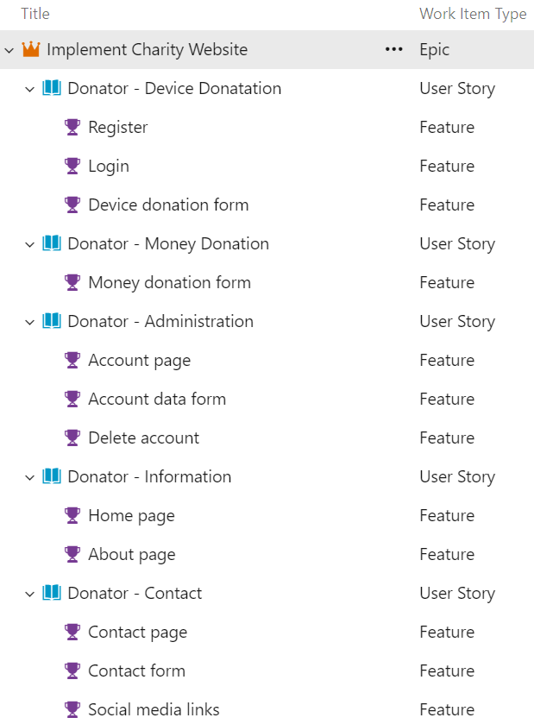





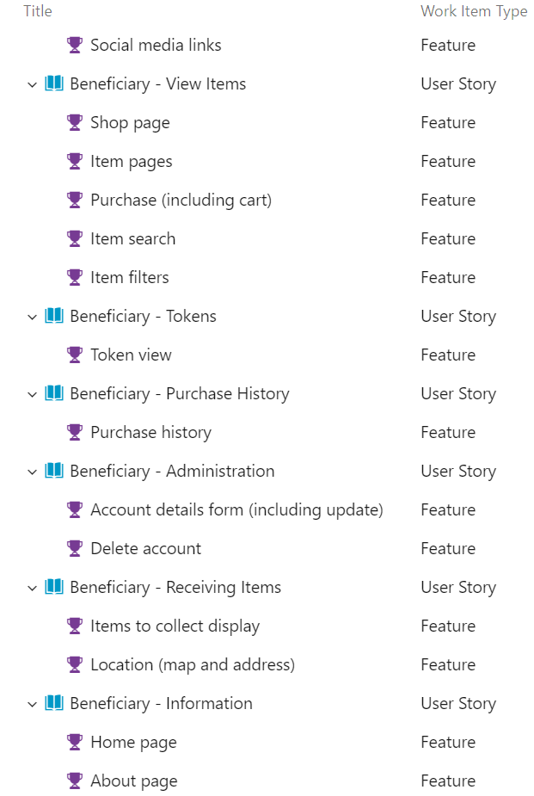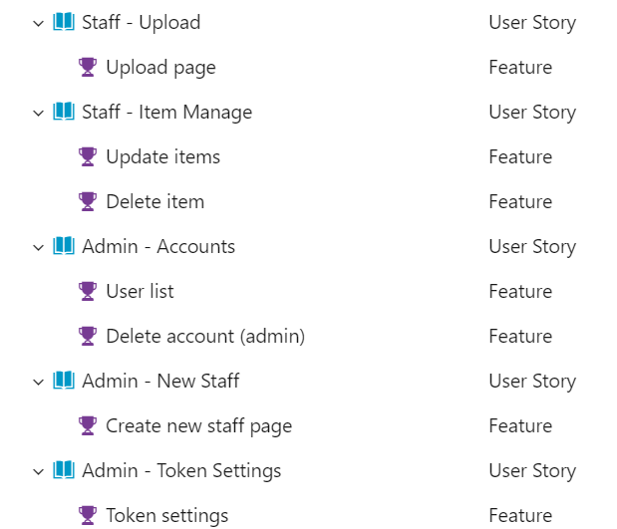

### CRUD Analysis

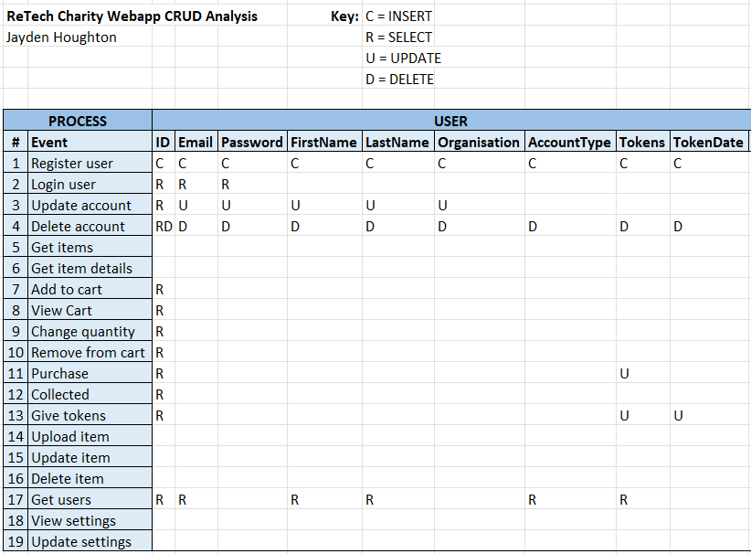

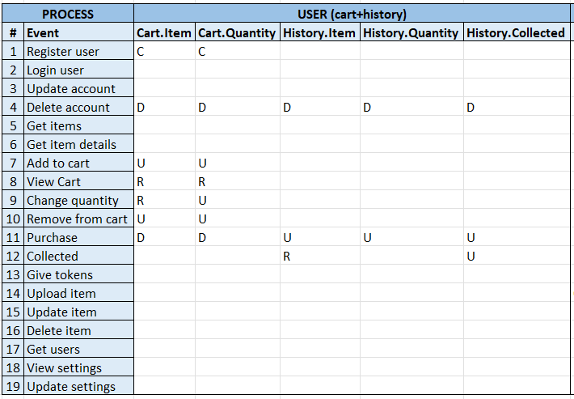

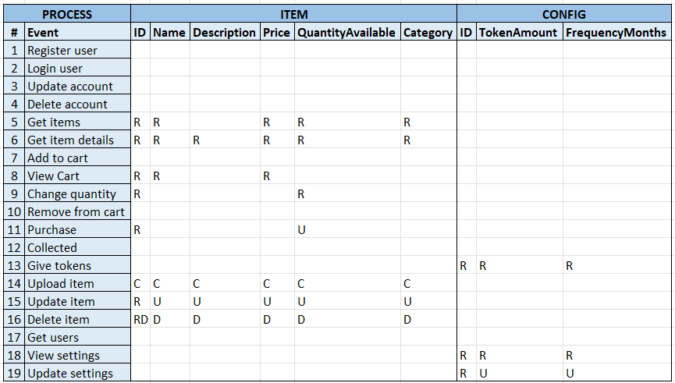

### API Prototype

Project at: <https://github.com/Jayden-Htn/WEB701_Project>

Note: some routes are used to perform multiple operations for different processes (e.g. user update can update user details, cart details, purchase history, and tokens as they are all stored as user details), however these can be split into multiple routes as required during implementation.

**Users Routes**

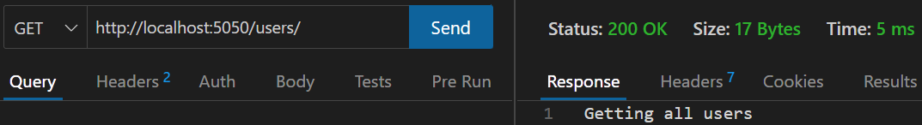

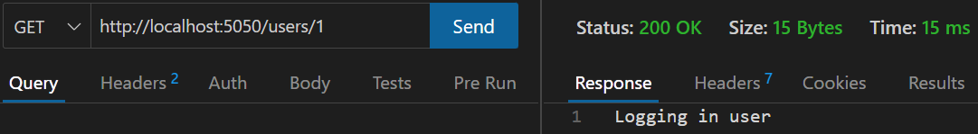

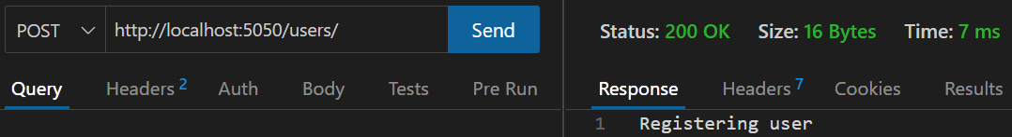

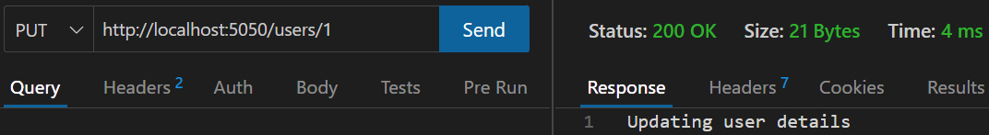

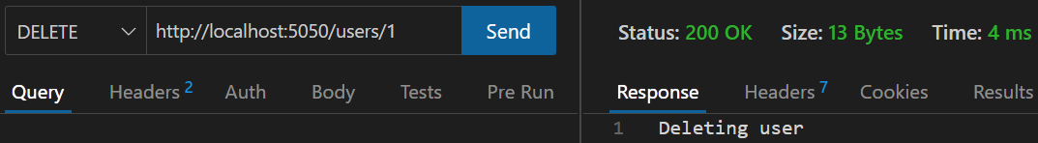

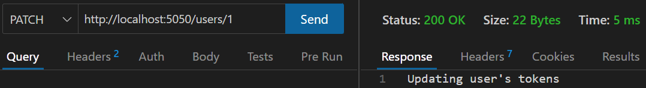

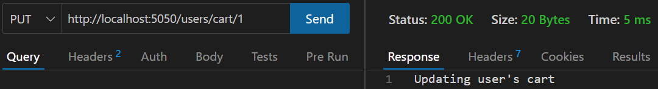

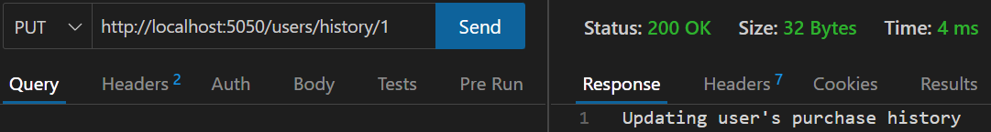

**Items Routes**

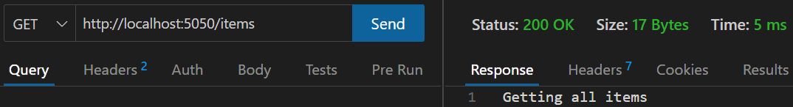

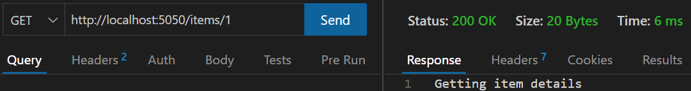

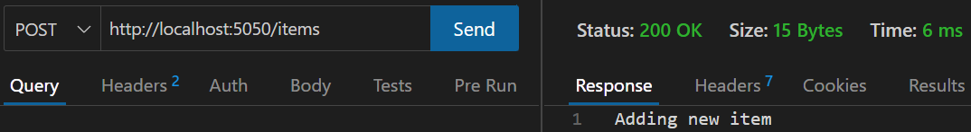

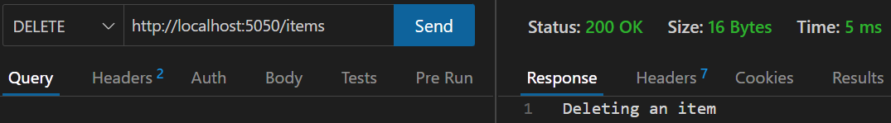

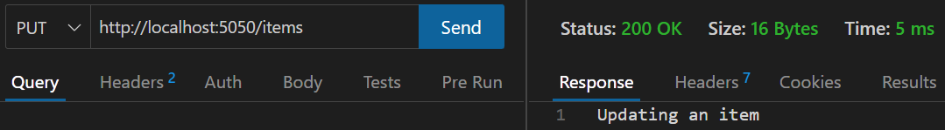

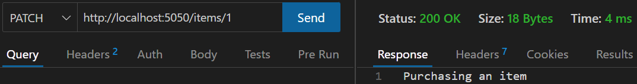

**Config Routes**

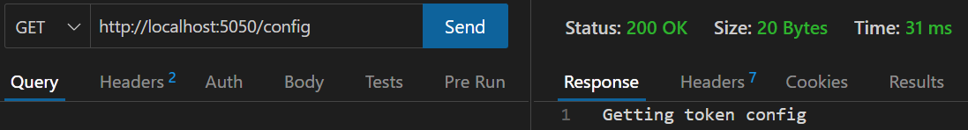

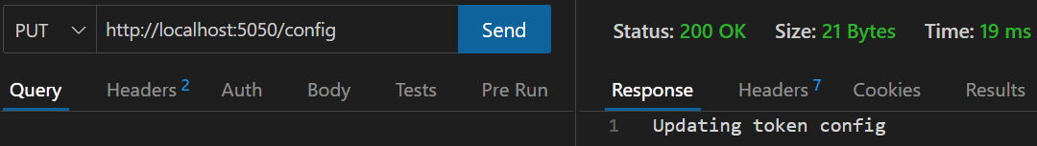

# Evaluation (Milestone 2)

## Purpose of Web Frameworks

Web development frameworks are sets of resources, tools, and practices that help developers build higher quality webapps in less time. Each framework works in different ways and offers different features, with common features being:

* They often provide structural rules or standards that help make maintenance and organisation simpler. In Angular, each component has its own folder in src/app, which holds the html, CSS, ts, and spec.ts files for that component. This set structure makes navigating components and finding the right code much more efficient and standard between different projects. This will be beneficial for my website as it will stay organised as it expands with new components and pages.
* They often provide starter apps or commands for creating components that reduces the manual work to get an app working, so developers can focus on the more complex work. In Angular, the *ng new <name>* command will create a new starter application and *ng generate component <component-name>* will generate all the files and a basic template for a new component (Angular, n.d.; Angular, 2023). This will help create my prototypes faster, making the development of the website more efficient.
* Many provide built-in testing functionality and integration of unit tests. For example, Angular comes with the Jasmin testing framework which allows running unit tests on the app through the command *ng test*. Tests are managed from the spec.ts file of each component (Angular, n.d.). This would provide a quick way to test that my website is working as I add new functionality and components.
* Code libraries with prebuilt components and code snippets to speed up development. For example, React has UI libraries of prebuilt, customisable components, that can be easily integrated into existing projects (Innocent, 2023). I can use this to integrate features like an AI chatbot much more efficiently than creating it from scratch.
* Many frameworks encourage high reusability of components, which means higher maintainability through less code. Both React and Angular allow for components to be impeded in many locations, so components can be built once and reused. I will do this with my nav bar and my chatbot overlay.
* Frameworks also have large communities of developers who can offer support and knowledge.
* Many frameworks provide improved performance. I can implement this through React’s virtual DOM. The virtual DOM is a lightweight copy of the real DOM that allows for less manipulation of the real DOM by only rendering what is needed, enhancing performance (Matéu.sh, 2024).

(Chatterjee, 2023; Sencha, 2024; Sheldon, n.d.)

## Emerging Technology

### Selected Technology

I have selected large language models (LLM) for my emerging technology. LLMs are a type of artificial intelligence (AI) that recognise text inputs and generate text outputs based on their large training data. They are built on machine learning, using a transformer model neural network (Cloudflare, n.d.). While AI is not a new concept, the idea has existed for thousands of years and early AI models were developed decades ago, the last few years has seen an extraordinary growth in AI’s capability to provide useful outputs, as well as the significantly increased rate of their implementation in other technology (Tableau, n.d.). LLMs have now developed to the point where they are being integrated into all-manner of websites and software.

I want to host my own small-scale LLM that is trained on information about my charity that will function as a chatbot on my website. Users will be able to open up the chatbot overlay and ask question to learn about how the charity works, who is eligible, etc. This can save time for users trying to find the right information and can help explaining it in a different way if they don’t understand the information initially.

### Implementation Investigation

There are many different models and hosting software that have been over the past months and couple of years, making it a very changeable environment. There are a number of considerations for selecting the most appropriate solution:

* The LLM must be pretrained to perform well with general conversation and be able to handle context.
* The LLM must be able to be fine-tuned on information about the charity in order to provide useful information.
* The LLM must be relatively small and require a relatively small amount of processing power in order to be run locally or have a free cloud version. This would save on the cost of using an AI API and avoid low performance.
* The LLM must be able to have an API endpoint in order to be accessed from the website.
* The LLM host must provide a suitable LLM option and should have a simple setup process.

From my research and comparison of potential options, I have identified a few strong options:

* Ollama has a wide variety of models available with decent capabilities. It is a simple and easy interface to setup and run models locally, while providing the capability to fine-tune and use and API endpoint.
* Hugging Face has a wide variety of models available with decent capabilities. It is capable of running models locally with Transformers (Python library), but also provides a limited free tier for cloud hosting, however with nonpersistent storage. It also has fine-tuning and API endpoints.
* GPT4All is a local software that runs arrange of models locally with decent capabilities. It has a simple visual interface but can also run in a server mode for Api calls and allows fine-tuning.
* Jan is a local software that runs arrange of models locally with decent capabilities. It has a simple visual interface but can also run in a server mode for Api calls and allows fine-tuning.
* LangChain is a Python framework for running local LLMs. It provides an easier code interface to integrate into applications than many other code-based interfaces. This could be set up with another module to handle API calls.

(Awan, 2024; Fernandez, 2024; Machlis, 2024)

All of the above options would work well in this scenario, providing strong performance, fine-tuning and API integration, however I have selected Ollama as my tool. It has suitable models for the size and chat type, strong performance, is easy to set up, allows fine-tuning, and can be stored in my GitHub repository. The ease-of-use and suitability for web integration made it stand out as the best selection (Awan, 2024; Fernandez, 2024; Machlis, 2024).

I will write a backend script that will handle downloading the model and training it on the charity information. This script will also handle API calls to generate responses, communicating with the rest of my website. Once the model is setup, I should be able to run and manage local instances of it to connect with each chat in the frontend. In order to save resources, a chat instance will only be loaded when a user opens up the chat.

### Impact on Internet Users

I expect that the implementation of AI and LLMs into websites will be a quick and large shift over the near future, especially with larger and more complex sites with lots of information. I believe this will have a significant impact of users, and how they interact with the web. I think that instead of users spending time trawling through numerous websites and pages to find the information they need, AI will become a middleman and be able to almost instantly compile the information requested in many situations.

I see this happening in two main ways to begin. First is AI being built into search engines, which is already a thing. Google has already been trialling AI Overviews, which aim to give to the search at the top of the page, eliminating the need to open any websites (Google, 2024). While this has so far resulted in incorrect, misleading, and even dangerous answers, like adding glue to stick cheese onto pizza, this will only improve as models and AI develop and become more reliable, which they are doing so rapidly (Goodwin, 2024).

The other way I see AI changing the web in the near future is AI being imbedded into websites themselves. For large websites with a lot of information, it can be hard to find the answers you need, where an AI chatbot could act as a middleman to find those answers for you, like a modern evolution of a search box. This is also happening already, with the NZ Government launching a virtual assistant called GovGPT. The Government is a huge organisation, with many departments, agencies, and thousands of pages, documents, and resources. GovGPT will provide a ‘digital front-door’ to users, allowing them to find the information they need in a much more convenient and efficient way (RNZ, 2024).

This is my goal for the implementation of my LLM in my website. I want it to act as a chatbot interface to allow users get the answers they need in a faster way. An AI interface also would have the benefits of allowing users to ask clarification questions or to reword answers if they do not understand, improving likelihood of users getting what they need. Users can explain their situation and ask if they qualify for assistance without having to determine that themselves, and an advanced version might even be able to register them automatically. As Attard (2023) discusses, users may be able to interact with websites through voice inputs to an AI to achieve their goals, which is a dramatic shift from the current visual point-and-click based interaction into a more organic, natural conversation-based interaction. An AI with speech inputs would also increase accessibility for vision impaired users, increasing the potential user base.

I believe that AI will be a commonplace tool which will make information even more accessible and efficient to find, saving users’ time.

## Evaluation and Comparison

I have selected React and Angular as my two frameworks for this comparison.

Please note the following:

* MongoDB Compass and Atlas must be installed for the backend to run on the Mongo localhost. When running the backend for either prototype, the example database will be set up.
* Both prototypes use the same Mongo database so changes will be reflected between them. Further instructions on how to run and use the prototypes are in the repository readme.
* Both frontends look and function virtually the same, so I have included one screenshot series for each functionality section to reduce unnecessary duplication.
* Both prototype backends are virtually the same, so I have only included commented screenshots from one, to avoid unnecessary duplication. The frontend code explanations have been done for both as they work significantly differently.
* This is just a prototype and does not reflect the full functionality of the application. E.g. the donator role is still to be added, and staff roles will not have tokens or purchases.

### Account System

#### Website Screenshots

Website when not logged in, showing home page.



Register page registering a beneficiary account.

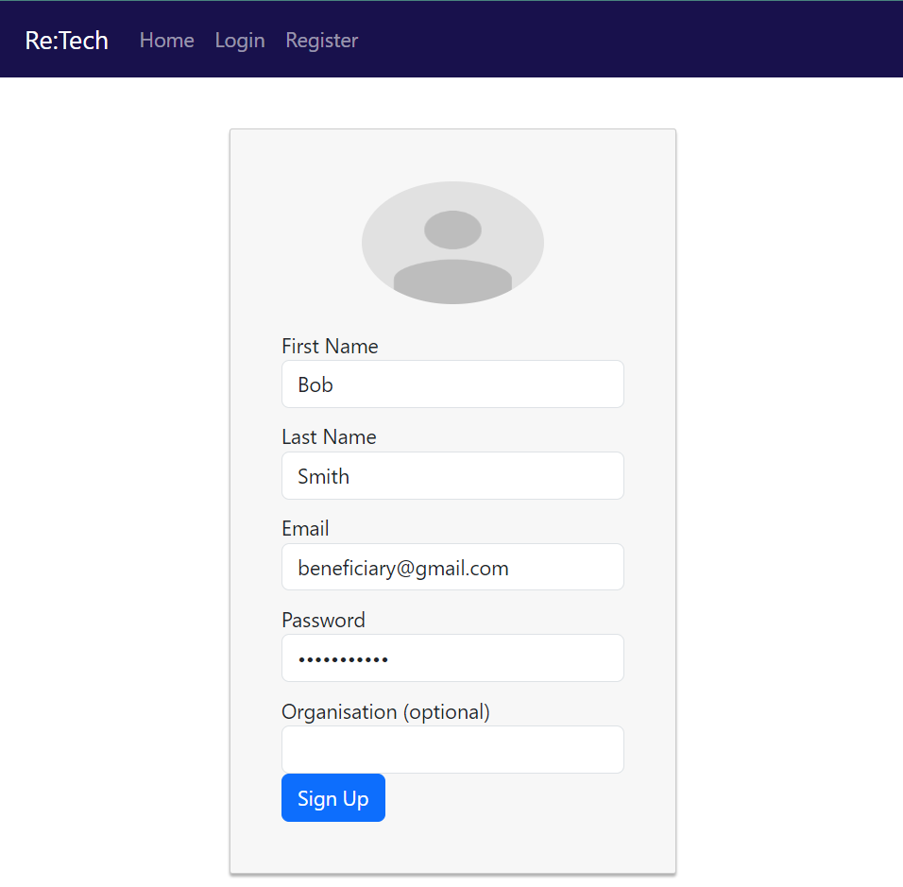

Alternatively, a beneficiary account logging into the platform.

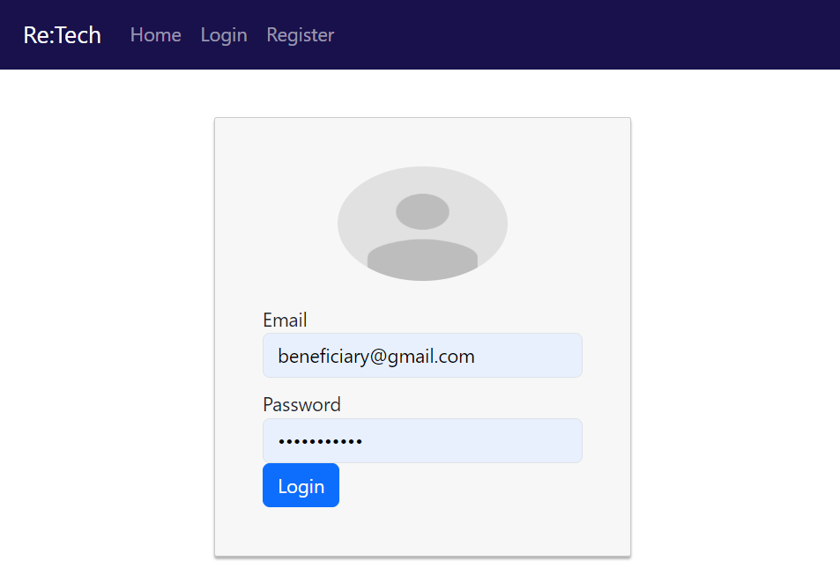

Once logged in or registered, the user can view their account details. Note how the user has the beneficiary role and can only view the shop, not the admin or staff pages. View the token transaction section for more detail on the shop page.

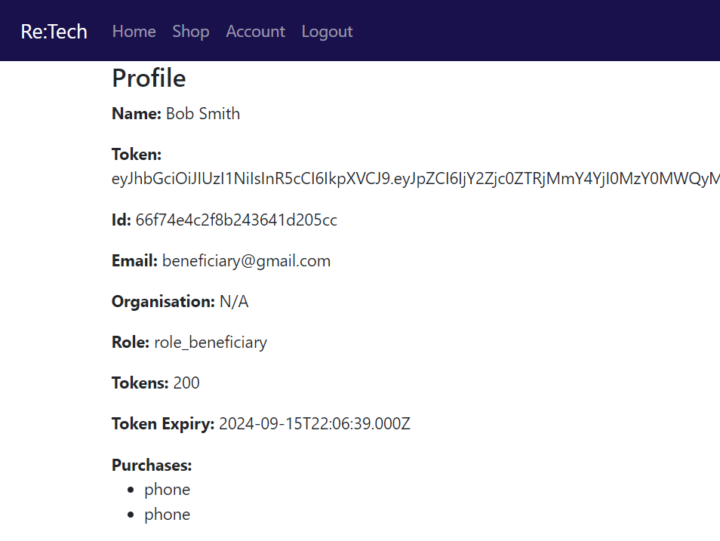

Staff account logged in show staff role and gives access to the staff page, but not admin or shop. Note: in the full version, the account pages for each account type will be different as staff and admins will not have tokens and purchases.

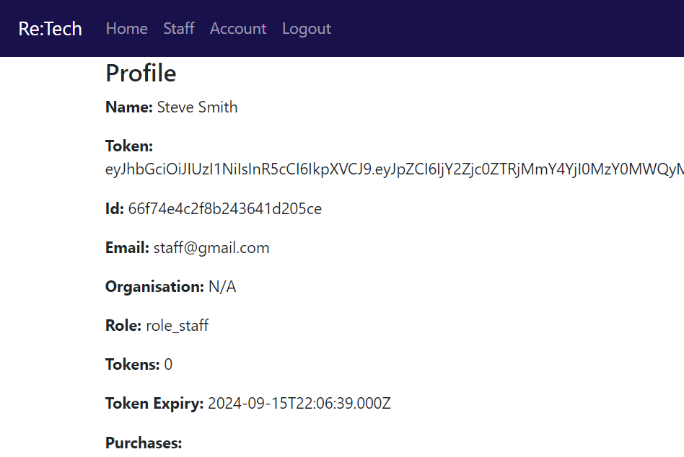

Staff content page will hold the functionality for uploading and managing shop items.



Admin accounts have the admin role and give access to the admin page, which will be for managing all user accounts. Note: in the full version, admin will also have access to the staff page.

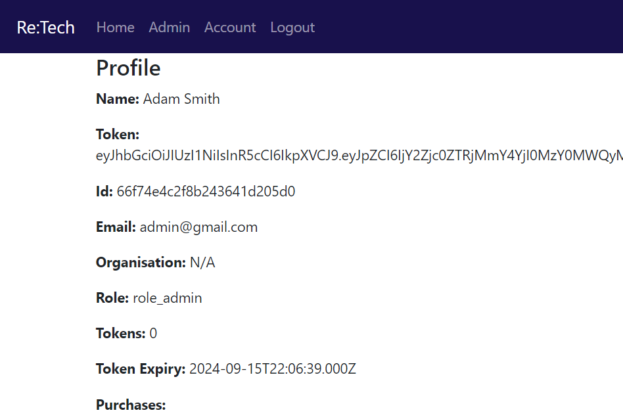

Admin page.



#### MERN

First, the user must enter account details into the login or register form (part of the login form shown here). React uses JSX (JavaScript XML), which works similar to standard html, but allows for extra processing and control.

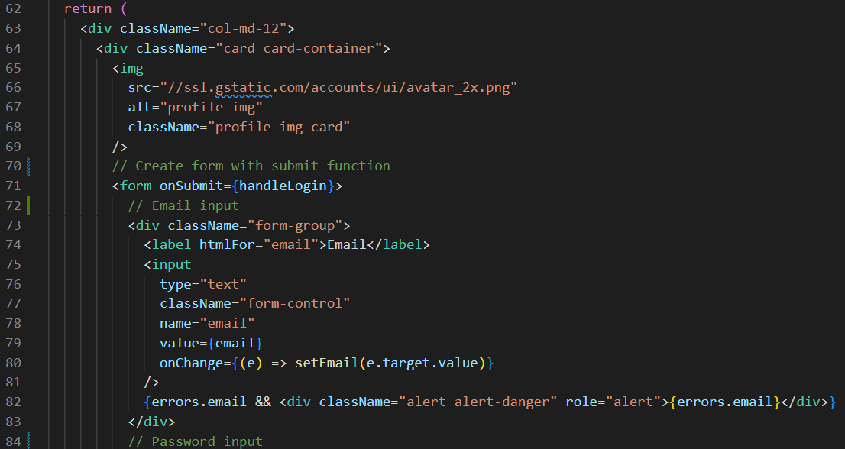

I have used conditional rendering using a JSX expression to only show a messages section if there is a message. This is done with the logical “and” (&&) operator.

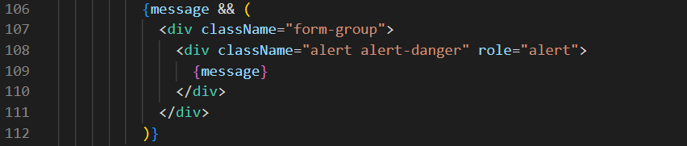

React uses use states to manage the states of different variables. In this case, as inputs in the form are changes, they call the use case setters, updating the variables.

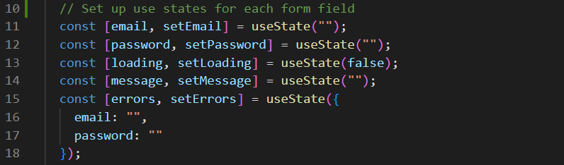

When the form is submitted, these variables are picked up, first being validated, then being sent to the backend via the auth service. If authentication is successful, the app will load the profile page, else it will display an error.

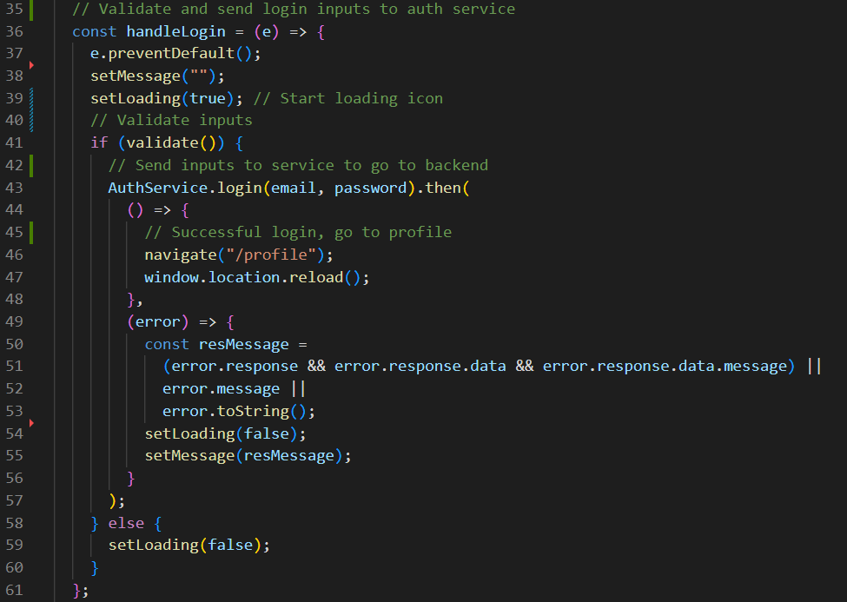

The auth service uses Axios to send a http request to the backend, setting the local storage with the user’s data if it is successful.

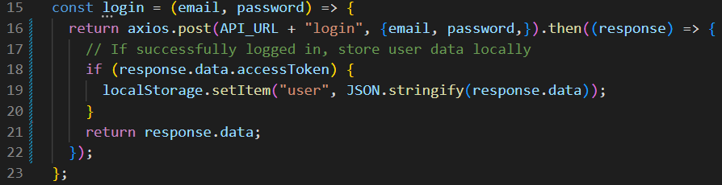

In the top level App.js file are more use hooks to manage which pages should be available to the user. When the user is logged in, the auth service gets the user and sets these use states based on the user roles.

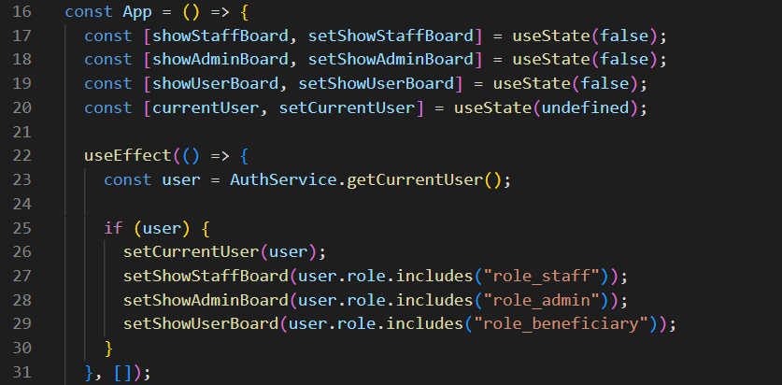

Nav bar links are shown using the same logical && evaluation, if the related use state is true, the expression will evaluate true and show the link.

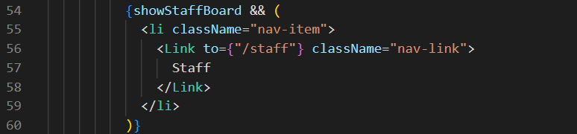

#### MEAN

First, the user must enter account details into the login or register form (part of the login form shown here). This is an html form using Angular functionality. For example, if the user successfully logs in, using *ngIf, the form will not show, and a success message will display instead.

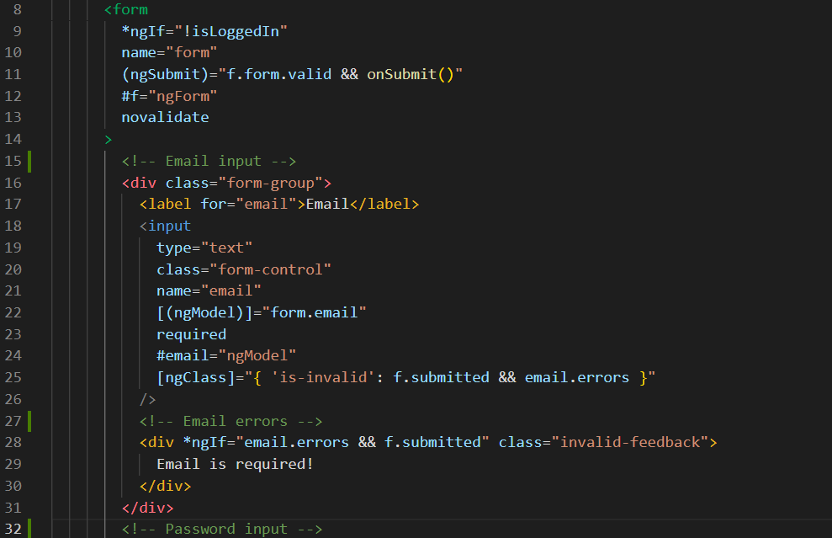

When the login form or register form are submitted, a submit method will retrieve the inputted information and send it to the auth service for authentication in the backend. If this returns successfully, the user is logged in, so the user data will be saved locally.

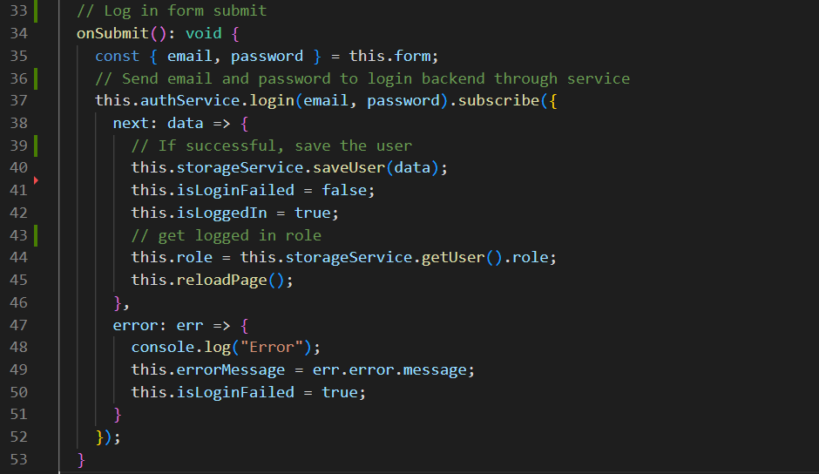

The auth service takes these user details and sends and Api call to the backend to authenticate the user.

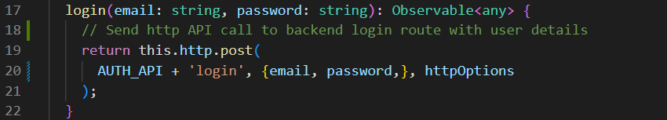

Please view backend section now.

The AppComponent class manages the states of the application, using the user’s roles to determine what pages are available. When the user log in is successful, this will get the user and determine which pages will be shown.

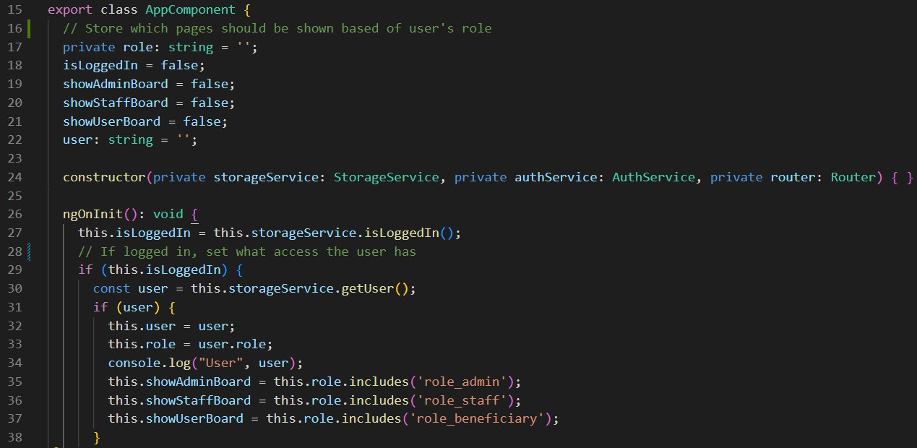



Depending on which boards are set to show, the app.component.html, which sets the nav bar will hide or show links in the nav bar to match the authorisation given.

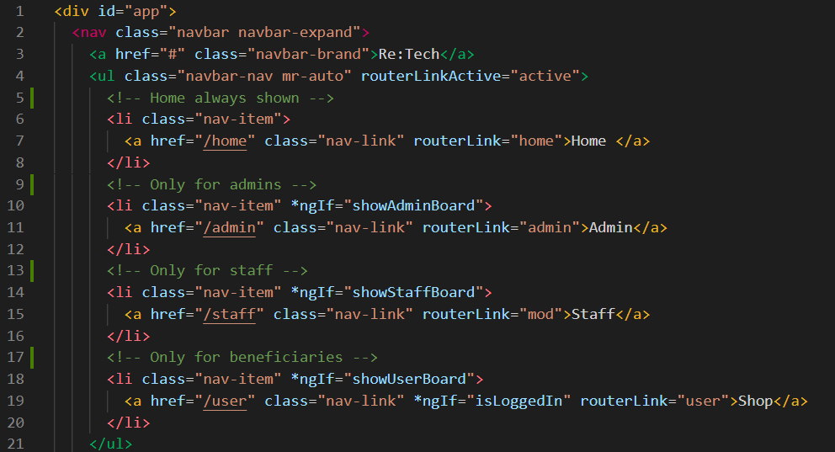

#### Backend Screenshots

The backend will send the API call through to the right route, in this case calling the login function in the auth controller.



First, mongoose will search to see if a user matches the email given. If it does, the role and purchases Object Ids will be populated with the actual records. The encrypted passwords will be compared, and if correct, a JWT token is generated and sent back with the user’s data to the frontend.

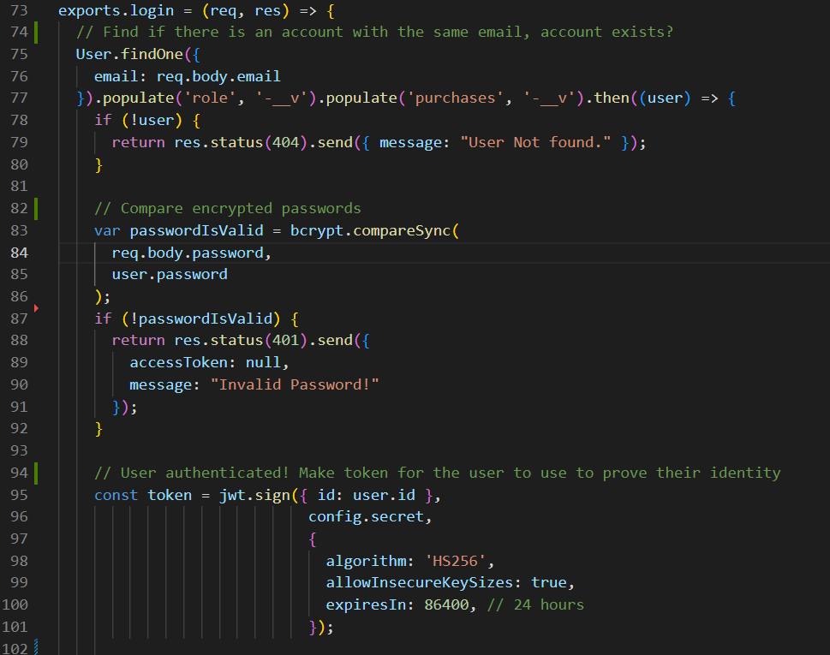

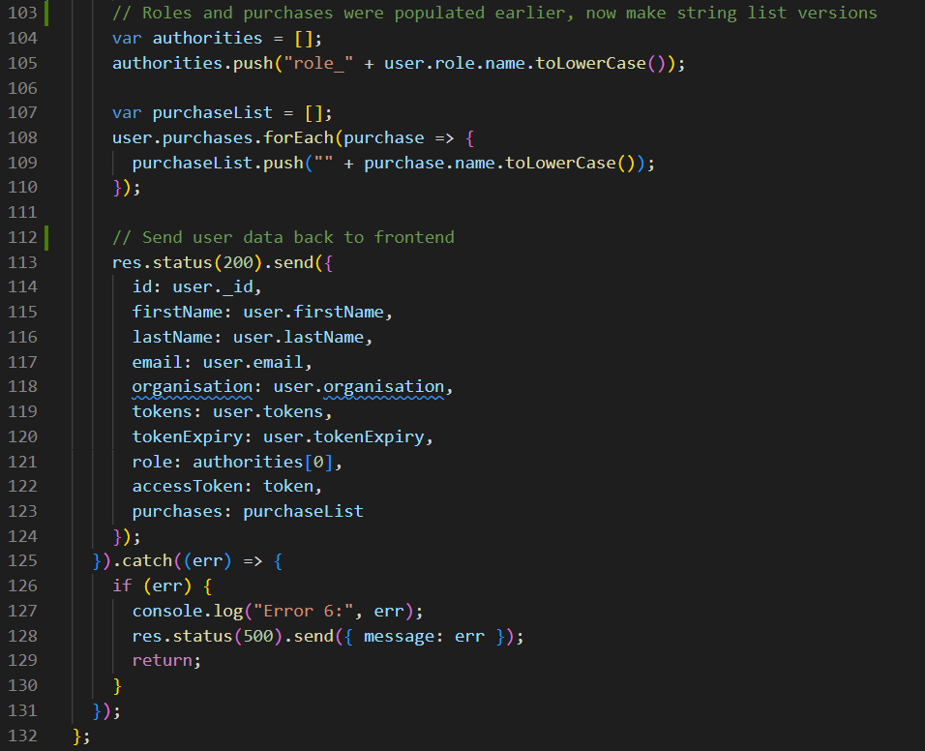

For the register process, the email must first be checked to make sure there is not already a role existing with it, as email must be unique. It must also check that the given role does exist. If both pass successfully, the register function in the auth controller will be run.

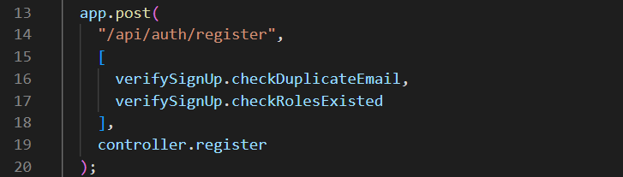

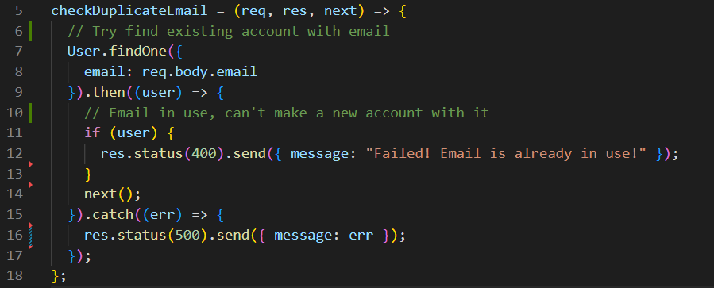

The register function constructs a user object to save to the database. If user roles are supplied, it finds the related objects in the database to map them, or just adds the beneficiary role as the default.

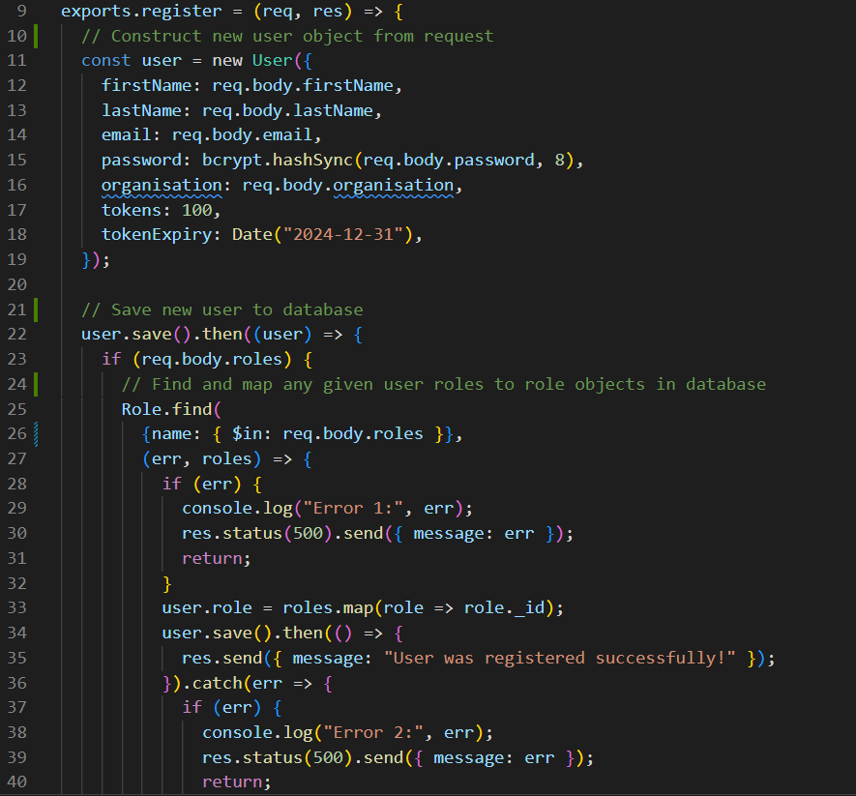



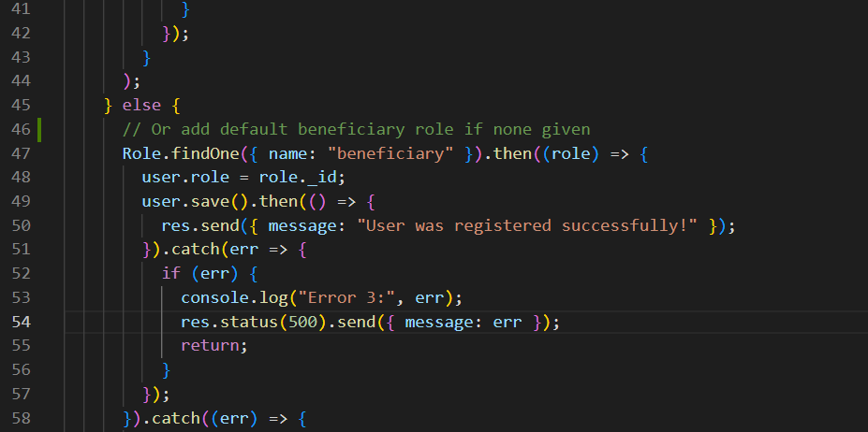

Currently users have to log in after register, so only a success message is passed back.

When getting the different pages locked by roles, the backend must check that the user has a valid token and that they are authorised to access that page.

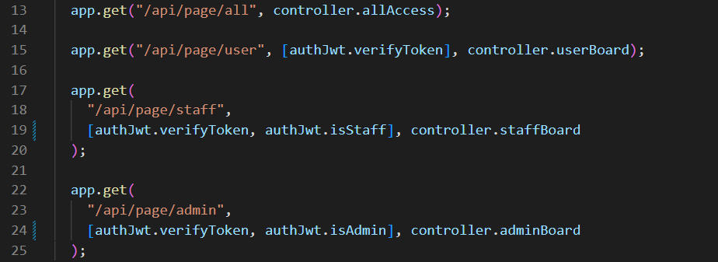

With the MEAN stack, the token is transferred with the bearer method, however in the MERN stack it is accessed via the x-access token method. This middleware verifies that the token provided is valid.



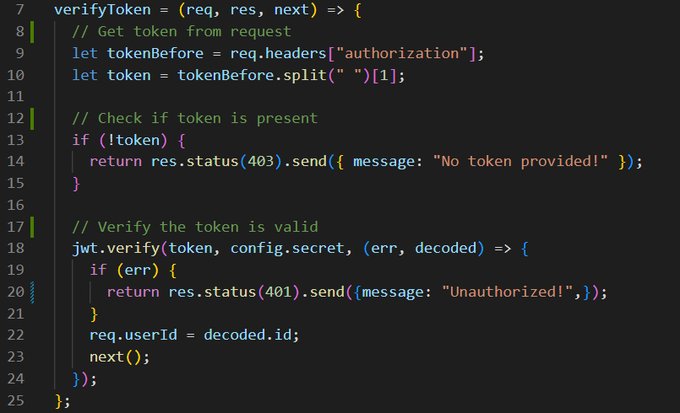

For pages locked by roles, the account must be first verified to hold that role. Here is the function to check that the user has permission to access the staff page.

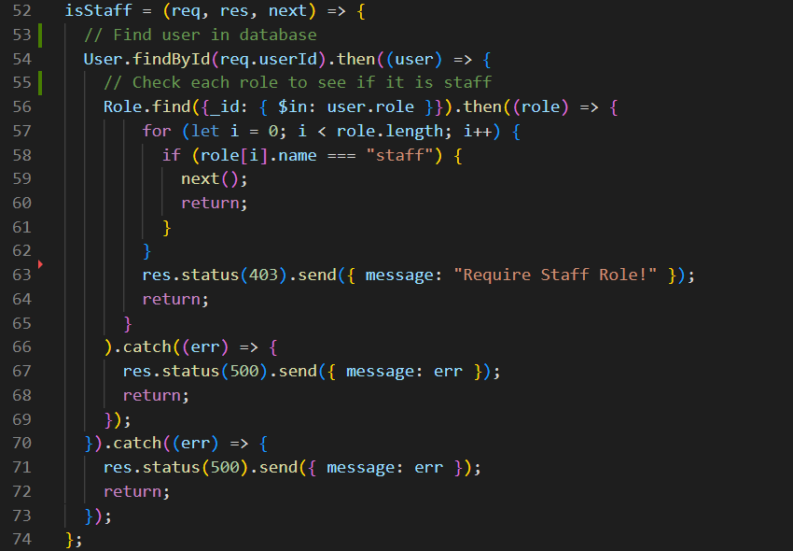

If all of the middleware passes, the controller returns the content for that page.

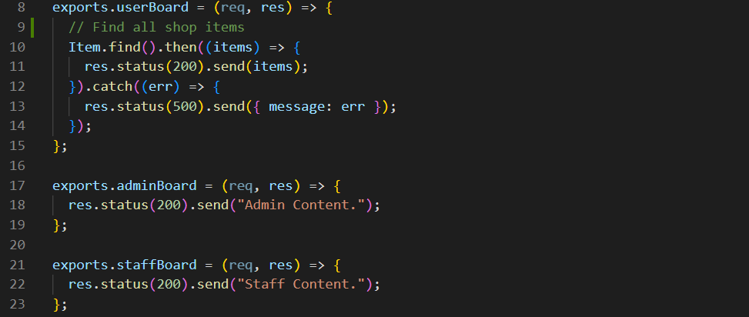

#### Comparison

Please refer to the MEAN and MERN sections of each requirement for an explanation of the solution in each framework.

I like Angular’s approach of a separate file for html, CSS, and logic (TS). I think this is a more logical separation of concerns and I find it easier to manage than putting everything in a single file like React, although the inclusion of all code for a component in one place does have benefits. The nature of using TypeScript to make classes and build components is a more complex application from my perspective, however. It has the additions of spec.ts files for additional clutter (in this case), and generally more complex and longer code with class constructors and component declarations, etc., which React seems to either not have or abstracts over so it feels simpler.

In terms of designing the pages in html, I like the simplicity of being able to use *ngIf to create simple render evaluations, which makes more logical sense then React’s method of a logical &&. Angular does however have much more complexity with it’s attributes. For example, the same email input has two additional attributes in Angular of ngModel and ngClass, which bulks out the code and makes it less clear to read. I also find it confusing at times reading all of the different annotations for databinding and other Angular features like *, () and [] with attribute names. JSX is simpler and works in a more logical way to be than Angular’s html.

With the logic, I do like how Angular uses regular variables versus use states, as it is easier to work with and much closer to normal JavaScript coding. Having to add “this.” In front of most variables or functions in Angular though is a bit tedious and feels unnecessary compared to standard JavaScript coding. I am more familiar with Reacts way of handing calls with then statements, so the syntax makes more sense to me, but I do like Angular’s way too. While TypeScript is fairly easy to pick up, I found that it does add extra parts of code that add to the overall complexity over standard JavaScript, and I did run into type issues at times. Having string types does have its benefits however it can increase time taken too.

Having a built-in API system in Angular is nice instead of using third-party libraries, however it works well and simply. I found Angular’s syntax a little more complex due to using Typescript.

Both frameworks provide powerful tools to create feature-rich applications, allowing me to create pages and manage states to show them based on roles, interact with the backend to perform database calls, manage data and create an interactive web application.

React complexity: 3

Angular complexity: 4

I find that overall React feels simpler and makes more sense with how it works. This is likely because I have worked with it longer, but I prefer the simplicity over the complex control Angular provides. React feels more intuitive and faster to use.

### Token Transaction

#### Website Screenshots

Firstly, users must be signed in to a beneficiary account.

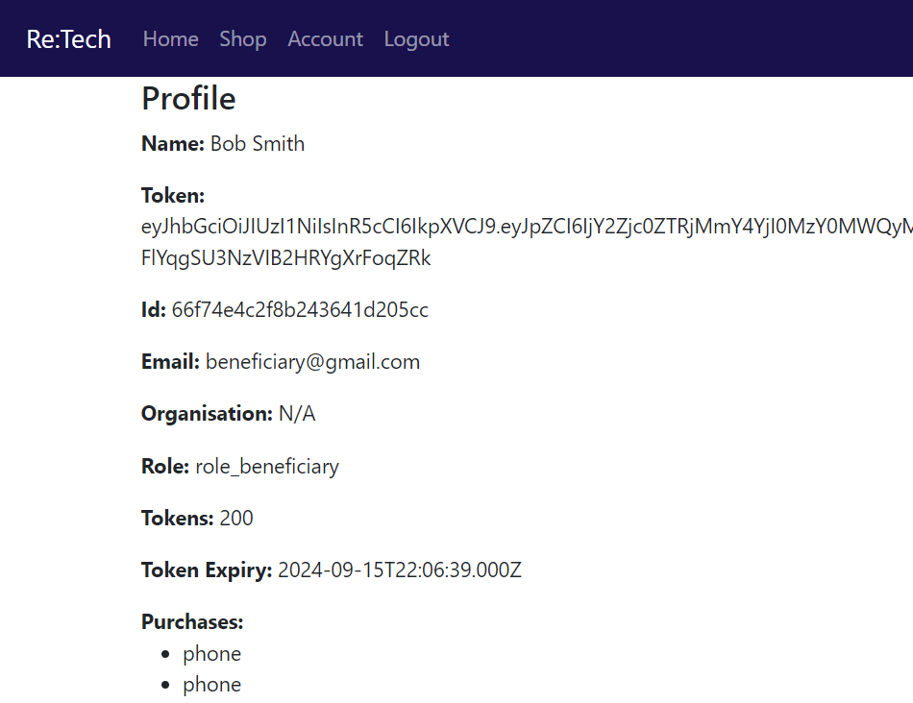

Clicking “Shop” in the nav bar will navigate to the shop page, displaying a list of basic items, including their quantity and price.

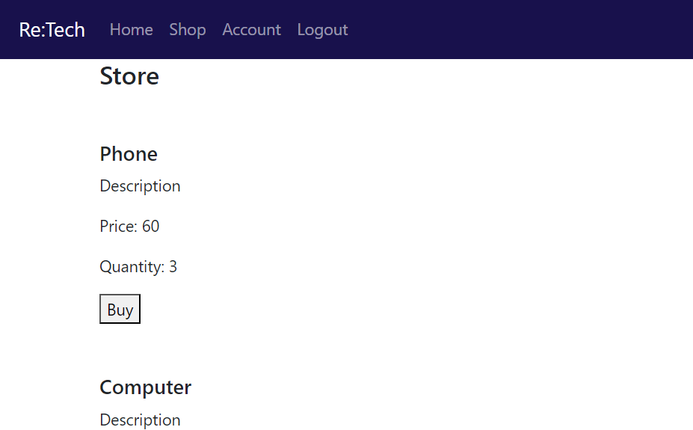

Clicking “buy” on any item (in this case the phone) will reduce that item’s quantity by 1, reduce the user’s tokens by the price and add it to their purchase list. Note: in the screenshot user’s tokens has gone from 200 to 140 and they now have an extra phone in their purchase list.

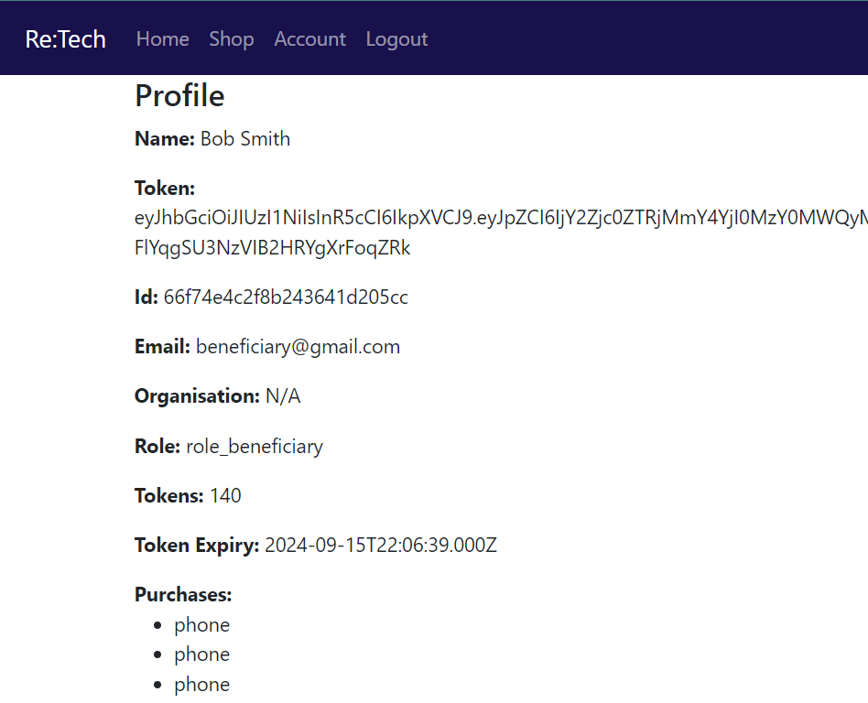

#### MERN Screenshots

This JSX section maps an array of items into an html card. It also includes a conditional operator to display a default message if there are no items.

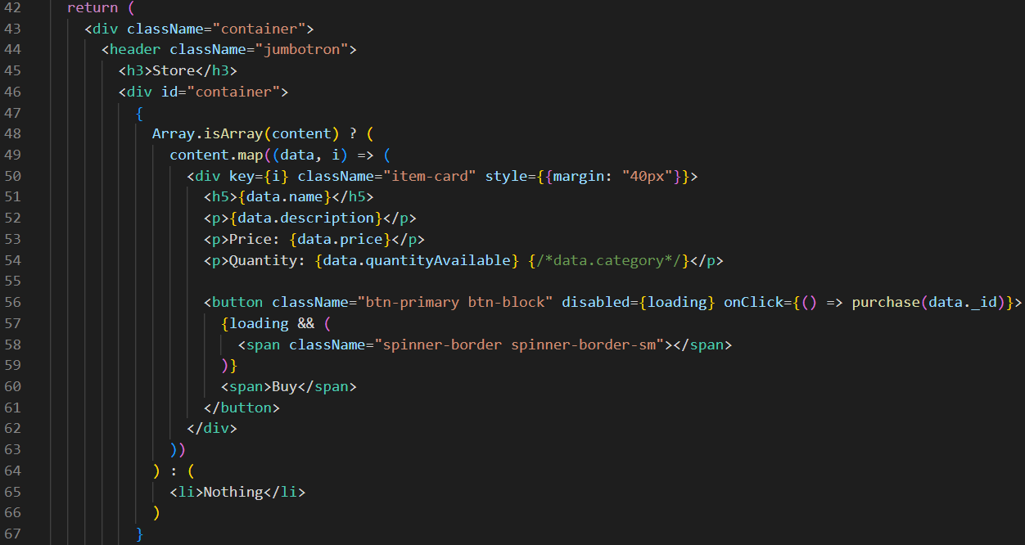

On purchase click, loading is set to true, displaying loading symbols and disabling any other buttons. The item id being purchased is sent to the shop service. If successful, loading is disabled, and the profile page is loaded with the updated user data.

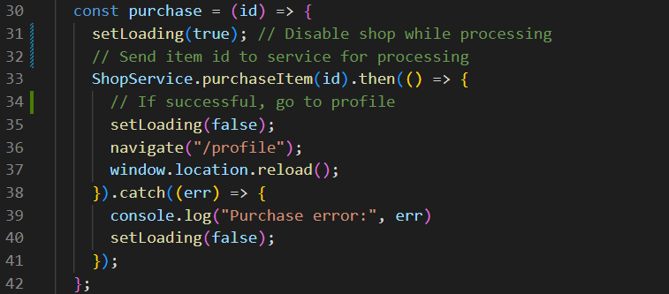

The shop service sends the id to the backend to make the purchase. Please view backend section now. If this comes back successfully, the updated tokens amount, and up dated user purchases are passed into an update function.

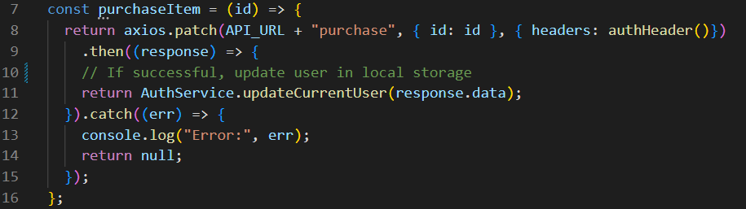

This gets the current user data, updates the tokens and purchases from the new purchases, and saves it locally. As the profile is loaded, it will get the new updated local data.

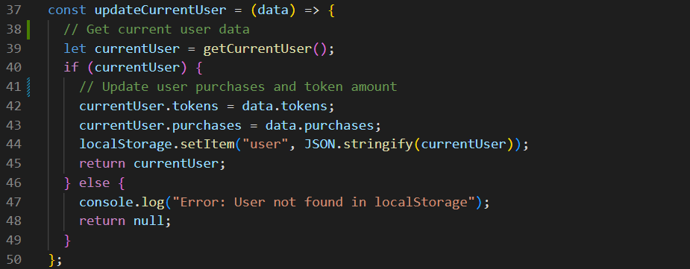

#### MEAN Screenshots

The Angular template uses *ngIf conditions to identify what to display. The array of items are mapped into an item component with *ngFor loop, similar to JavaScript.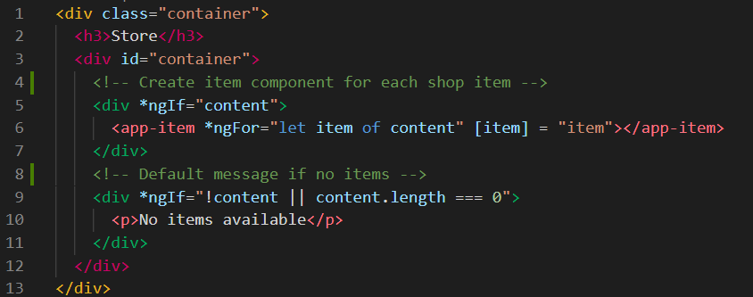

The item template simply gets the data from each item of the for loop and adds it to the card html.

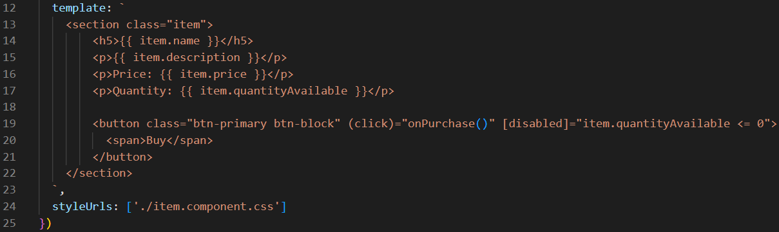

Selecting the purchase button first checks if there is an item to purchase (also checked in the backend), before sending the item id to the shop service. On a successful purchase, the profile page is loaded.

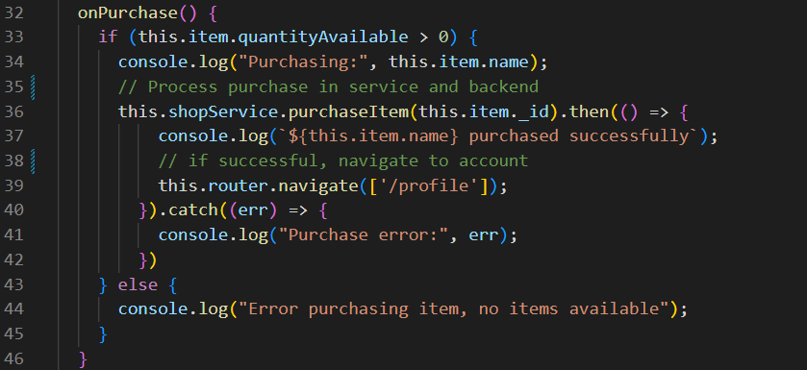

The shop service sends the item id to the backend for purchasing. On successful purchase, the new token amount and purchases list is sent to the storage service to update the local data.

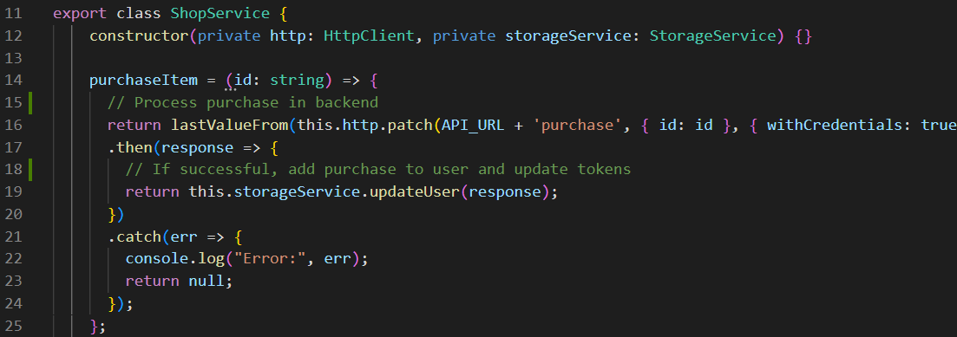

This gets the current local data, updates the token and purchases values, before resaving the local data. When the profile is loaded, it will display the new data.

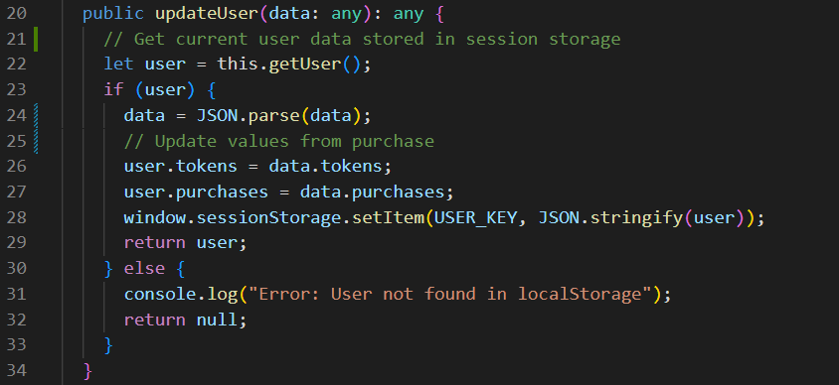

#### Backend Screenshots

The backend will send the API call through to the right route. First, it will verify the user’s JWT token, then process the purchase.



The token is received through the request header (MEAN version) and verified.

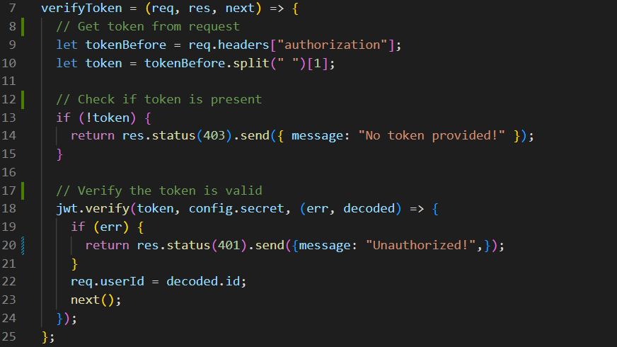

To purchase an item, first the item is found using its id from the database. If there is one or more available, it will find the user in the database. If the user is found, the item and user are both updated with the purchase. The item quantity is reduced, user tokens reduced, and the item added to the user’s purchases. The new token and purchase list values are returned to be updated locally.

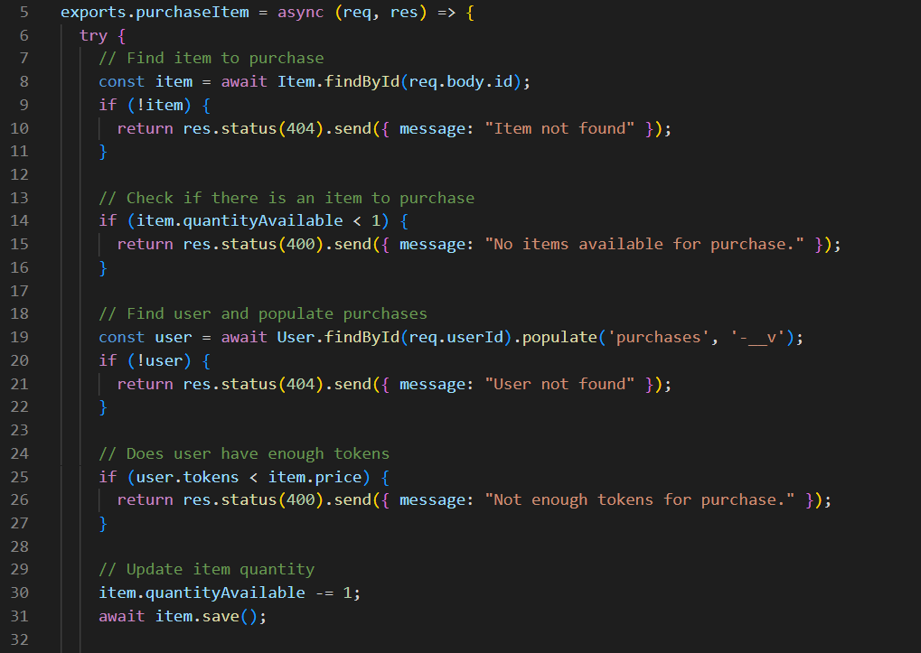

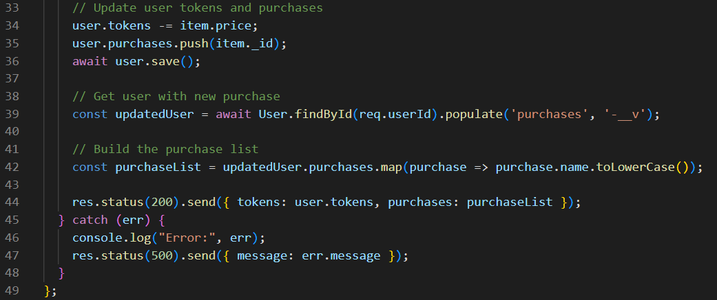

#### Comparison

Please refer to the MEAN and MERN sections of each requirement for an explanation of the solution in each framework.

For templating the shop page, I think that the Angular method is simpler from a readability and logical point of view. The *ngFor operator allows for very easy iteration over an array to make components, however this does then split logical and code over two components instead of all in the shop component, which may be good or bad in different cases. While the React version is less clean, I find it makes more sense to me as I have done the same thing before in other projects, so it is more familiar. While Angular is simple and clean once working, it took a lot more time to work out and understand.

The purchase functions were fairly similar, and work is very similar ways.

I did have some issues with Angular’s shop service and API communication. React’s API was very easy to string on processing with then catch blocks, however I had a lot of issues getting the syntax right with Angular to achieve the same thing. Angular also seems to randomly stringify objects here which React doesn’t, which caused a lot of debugging in the update user function. I also have difficulty getting Angular to send credentials correctly to the backend, also taking much more time.

Both frameworks allowed me to get item data from the backend and display it in logical, dynamic ways with templating to achieve the same shop-front experience. They both allowed me to handle communications with the backend to process actions and manage local states and storage of data.

React complexity: 3

Angular complexity: 5

I found that I had much more issues and difficulty getting Angular to work than React, so it took much more time, especially over what should have been simple things.

### Data Retrieval

#### Website Screenshots

When logged into any account, the user data will be displayed on the profile page. Note: staff, admin and donators currently have the same data, but will not have tokens, token expiry or organisation.



#### MERN Screenshots

When users log in (see account system section), data is retrieved from the database. This is displayed in a simple JSX template. I used another conditional operator to map the purchases to a list.

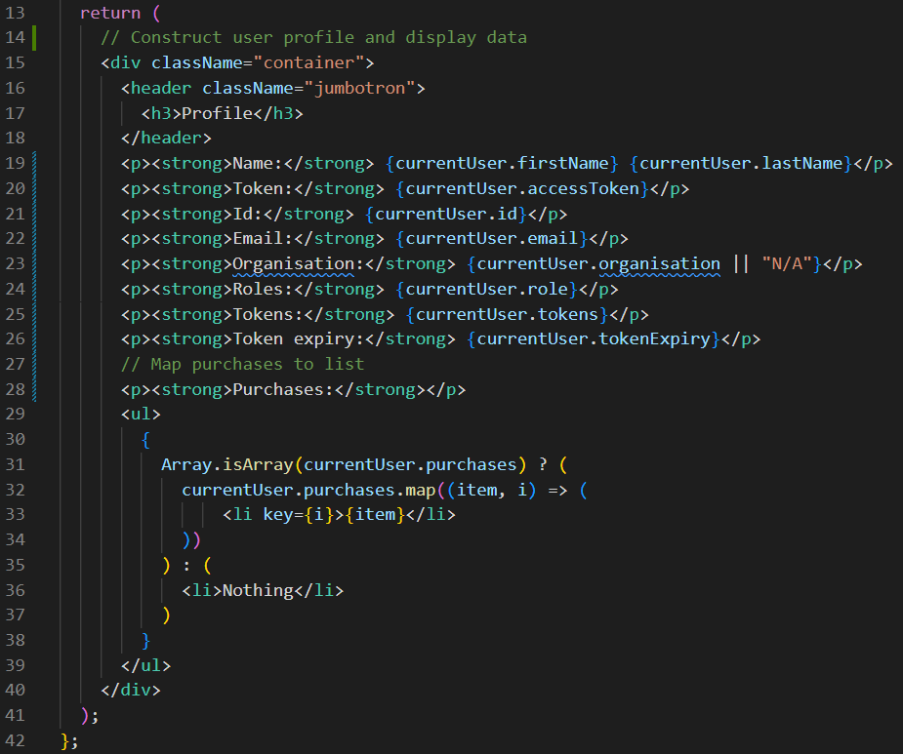

Data is retrieved from the local storage (set from logging in) with a use state into a local variable used in the JSX template.

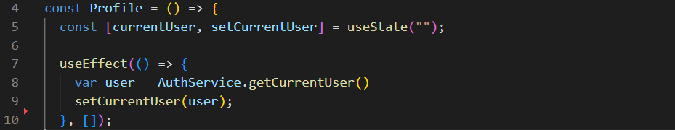

#### MEAN Screenshots

The Angular template works very similar to the JSX, simply referencing a variable to display the data. I used an *ngFor loop to map the purchases array to a list.

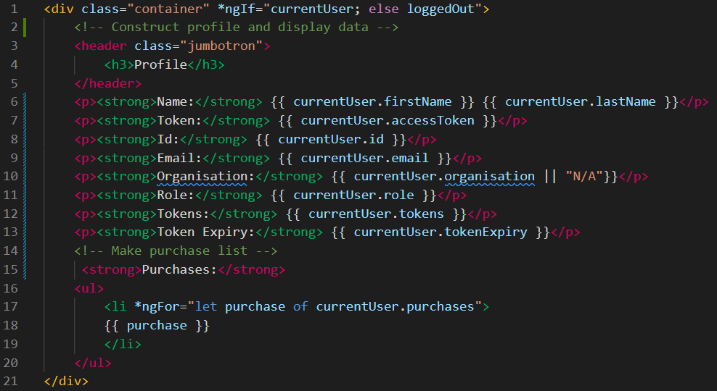

When this component is loaded, it retrieves the current user from the local storage.

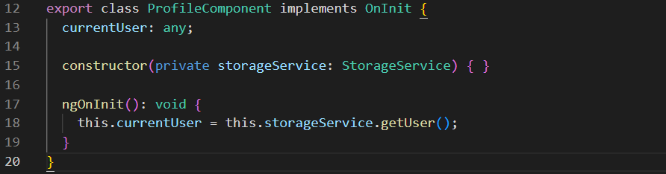

#### Backend Screenshots

User data is returned through the login process. Please refer to the account system backend screenshots.

#### Comparison

Please refer to the MEAN and MERN sections of each requirement for an explanation of the solution in each framework.

In terms of templating, both are very similar, using basic html to build the profile. React’s single curly brace style is simpler, but otherwise the data display works the same. The purchases list in Angular is simpler once I worked out how to do it. I like the ability to simply write a simple loop in the tag using *ngFor. React is slightly more complex and definitely longer for this part, however it is still simple to understand for me. I do like how Angular templates use the same colouring as html, where JSX all uses the same colour.

Data retrieval from the service is simpler in Angular, using just a simple variable and function call, whereas React uses a use effect. This is more complex but also relatively simple to manage. Data retrieval in the service is the same.

Both frameworks allow me to get local data and display it using html and CSS, using mapping or loops to achieve dynamic lists of data using simple means

React complexity: 3

Angular complexity: 2

I found that both were fairly simple, but Angular was slightly more concise and simpler in its ability to get and display data.

## Framework Recommendation

**Complexity Rating**

0: easy, 15: complex

|  |  |  |  |  |
| --- | --- | --- | --- | --- |
|  | Accounts | Transactions | Data | Total |
| React | 3 | 3 | 3 | 9/15 |
| Angular | 4 | 5 | 2 | 11/15 |

Based on my experience of building prototypes in both React and Angular, I recommend building this project with React.

React generally has a simpler syntax and learning curve that is more similar to standard JavaScript practices. This makes it much easier for me to understand and become familiar with, saving me lots of development time.

Angular does have some useful features like *ngIf and *ngFor, however overall, it is much more complex, with more files and more lines of code. TypeScript does provide extra security with data handling, however I found this to be detrimental during my development.

An all-included framework like Angular is beneficial as it keeps required modules more uniform and consistent, but for this project, not many additional packages were required for the React prototype, so this does not make much difference.

React is generally more suited for small to mid-sized applications, whereas Angular is designed for large enterprise applications. This project is being done in a limited time and is definitely not an enterprise application, so some of Angular’s features or building style could be considered overkill or unnecessary, just increasing development time.

Both frameworks are powerful tools, with high capabilities that enable met to build everything I need for my eCommerce application, however the simplicity and reduced development time React offers for this project cannot be ignored. I believe that React is the more suitable choice for this project.

# Development (Milestone 3)

## Functional Implementation

I think that overall React is well suited to implementing a medium-scale interactive webstore just as I have done for this project. It provides a suggested structure/framework to organise applications in a logical manner, provides the necessary functionality for building a single page application such a routing management, faster performance for rendering more complex web pages, as well as separation of concern and reusability with components. All of these feature’s help build better applications without the unnecessary complexities of other frameworks like Angular. React fits well into the middle ground, which was perfect for this project. The combination of all of my selected technologies worked well together and allowed me to build a feature-rich, secure, and robust application.

### Authentication & Administration

*Charity members and beneficiaries can register, log in and administer their own accounts.*

From my original prototype, I already had an accounts system that allowed beneficiaries, staff, and administrators to login to their accounts, as well as allowing new members to register as beneficiaries. This used React forms to collect and validate inputs, a frontend service with Axios to send data to the backend API, middleware to validate values, and controllers to handle login and registration.

From here, I repurposed the registration form into a profile detail form, which I implemented into my profile page. I built a new service request, route, and backend controller to handle updating accounts with new data. This is available on every account, no matter the type. The hardest part of this implementation was allowing emails to be changed. An email can be changed if the new email is not already being used, but the current email must be accepted if other details are being updated, even though it is used by an account. To fix this, I had to adapt an existing middleware that is used for registration to check if a new email is valid, but it also accepts the existing email for an account.

Next, I had to create a new role for donators, and update the registration form with a dropdown, so the user can register as a beneficiary or donator. With the new donator role, I had to update the main app to handle the new role, including adding a new nav link and updating the role setups. I implemented a donator page, which holds a device donation form. Realistically, this would go to the staff to process first before being uploaded to the shop, but for demonstration purposes, new items immediately appear in the shop for beneficiaries.

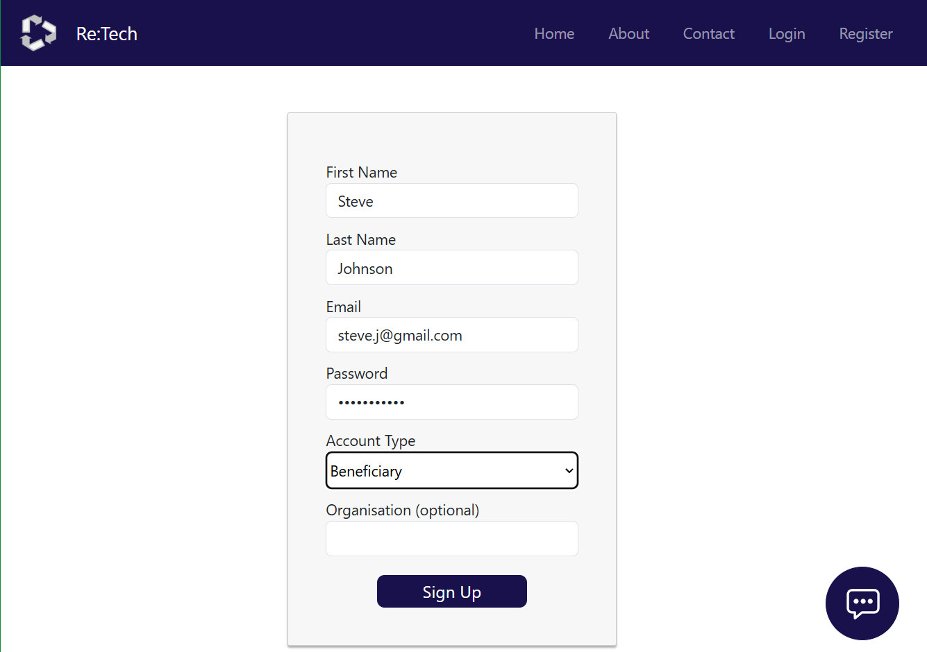

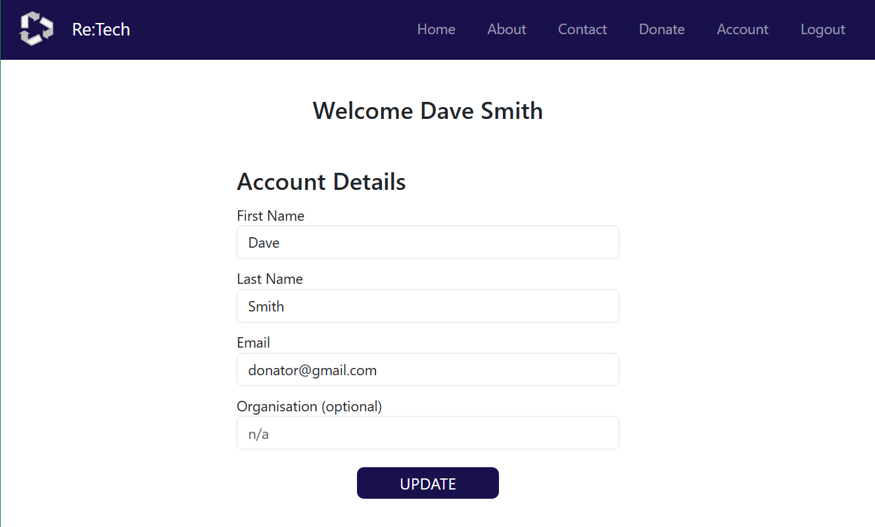

I have tested these features thoroughly through development and have fixed any identified errors. They should be working correctly.

**Critique**

React is a common framework to use for this type of application, so it is well suited and works well. The form I have implemented with JSX, along with use states to manage values lets me easily validate inputs and handle value changes. This was fairly straightforward to implement. JWT tokens are a standard method of managing user tokens for authentication. It works well and was easy to implement. I think JWT is currently the best tool available for its purpose.

While validate was easy to implement in React, it must be done separately to the form, adding length and separation.

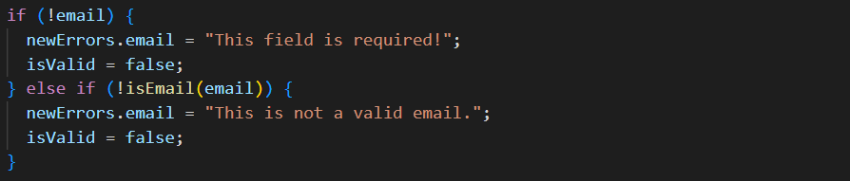

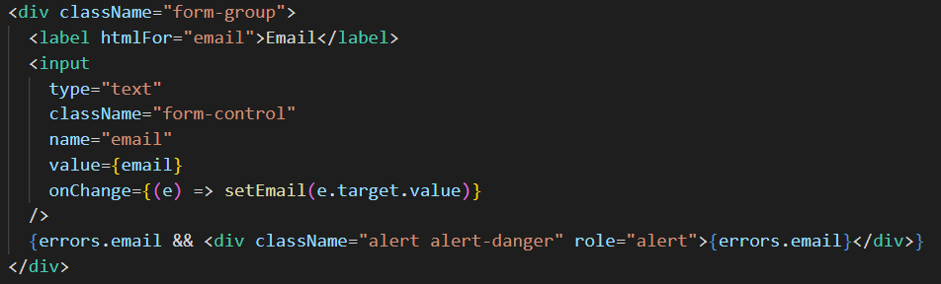

Angular allows for validation and error display to be handled directly in the form along with each form element. This helps contain logic together and utilises some of Angular’s built-in error handling, which arguable results in cleaner code.

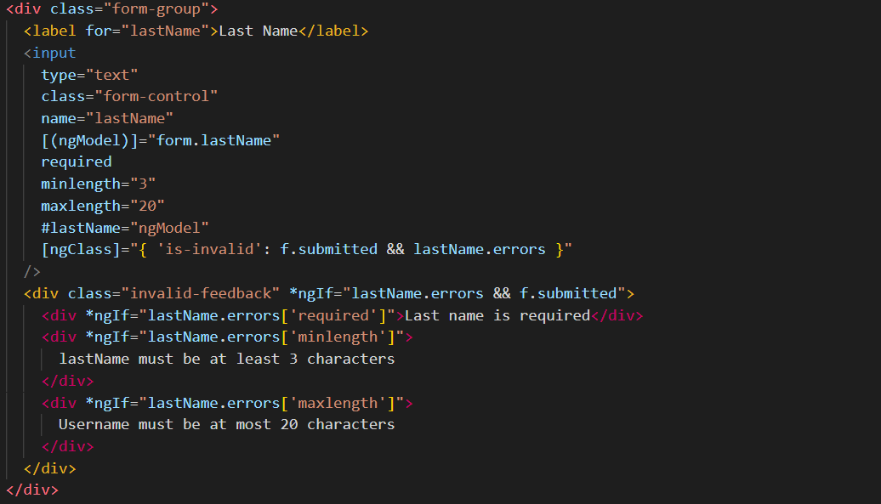

Other than this, implementing this requirement with another framework would look very similar.

### Product Registration & Tokens

*Members use the website to register their products and services, and beneficiaries use the system to acquire tokens.*

From my original prototype, I had a beneficiary role that had tokens, but I had no donator or donation ability. Currently each account is assigned 100 tokens when the account is created. In a future version, tokens would be reassigned every 6 months to allow beneficiaries to acquire more items.

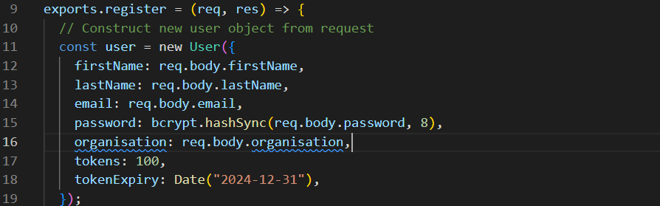

To build the donation functionality, I first made the donator role as discussed in the section above. From here, it was easy to create a new page and donation form based off existing pages and forms I had created. This simply involved adapting the form to suit new inputs and making a few tweaks to ensure that the page links and values were all correct.

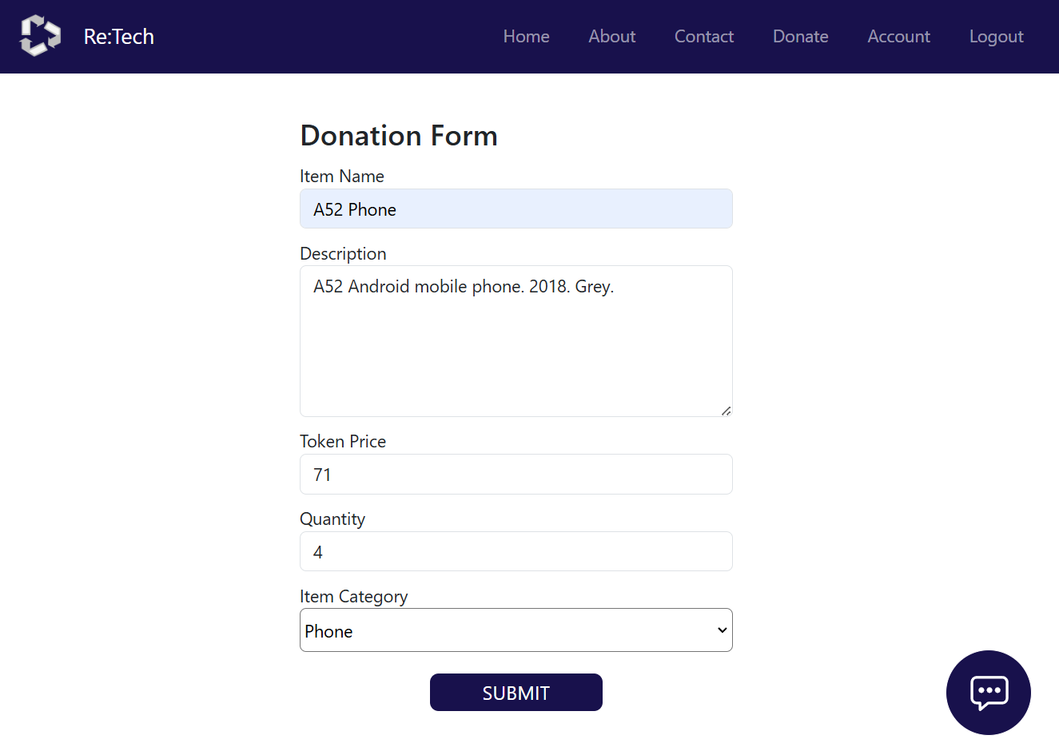

Next, I built the frontend service, routes and controller to handle adding a new item. Realistically, new items would be handled by staff first before being uploaded to the shop, but for the demonstration of this system, they are uploaded immediately. The backend controller is simple, it just creates a new item with the supplied values and saves it to the database.

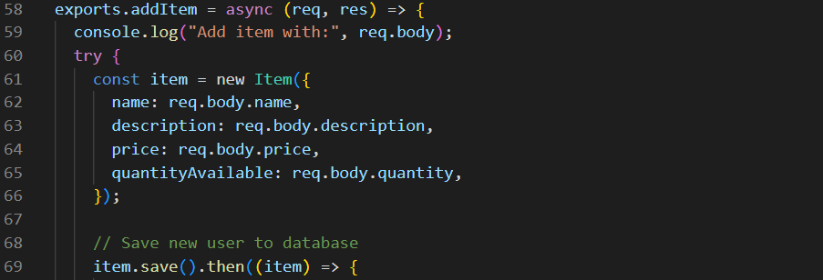

I have tested these features thoroughly through development and have fixed any identified errors. They should be working correctly.

**Critique**

There is not much I can critique in terms of my design and implementation, as the feature is very straightforward and there are not many alternative options.

I have decided to use the same user model with the same fields for every use, no matter the role. This means that all users, including staff and donators technically have a tokens field, even though it is set to zero. I chose to do this for simplicity of building the prototype, however it would be more secure and logically better for users to only have fields related to their role. As Mongo is flexible, I should be able to create users without their unnecessary fields, reducing clutter for a cleaner solution.

Realistically, the item model should also include other information, such as images, so users can fully understand the product they are purchasing.

Like discussed in the above section, Angular allows for validation to be displayed in the form instead of separately, which allows for a cleaner solution than Reacts version, however the simplicity and logic of the rest of React makes much more sense to me, making development much easier, so the trade-off is worthwhile.

### Interactive Elements

*Interactive element(s) that engages the website user.*

I have implemented a simple but visually appealing theme based on my original wireframes, mockup and colour palette. I constructed most layouts using a flexbox-based based structure to give flexibility and responsiveness. I have gone for a modern clean look, using solid colours, and rounded corners for cards to create an easy interface for users to understand and use.

I decided to implement my styling through CSS modules, which I have not done before. I created a global stylesheet for any app level or global styles, and then component level CSS stylesheet, so each component has its own styles. Each stylesheet is imported into the relevant component file.



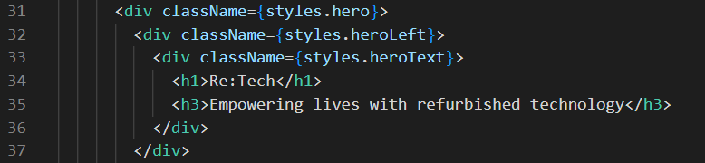

My original prototype had minimal styling and layouts, so I had to build almost all of the pages and styling for this assessment. While this has simple work to do, it did take a reasonable amount of time to do.

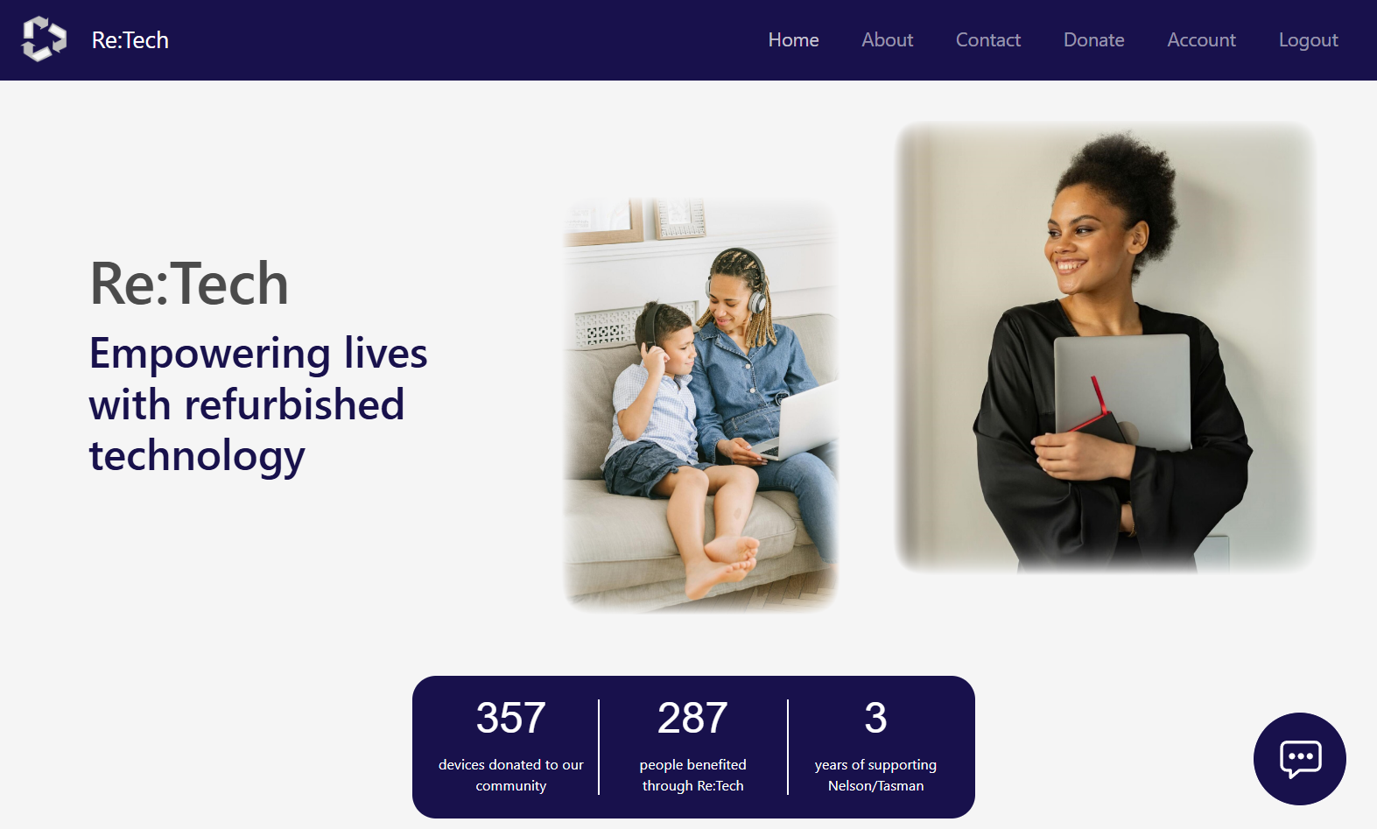

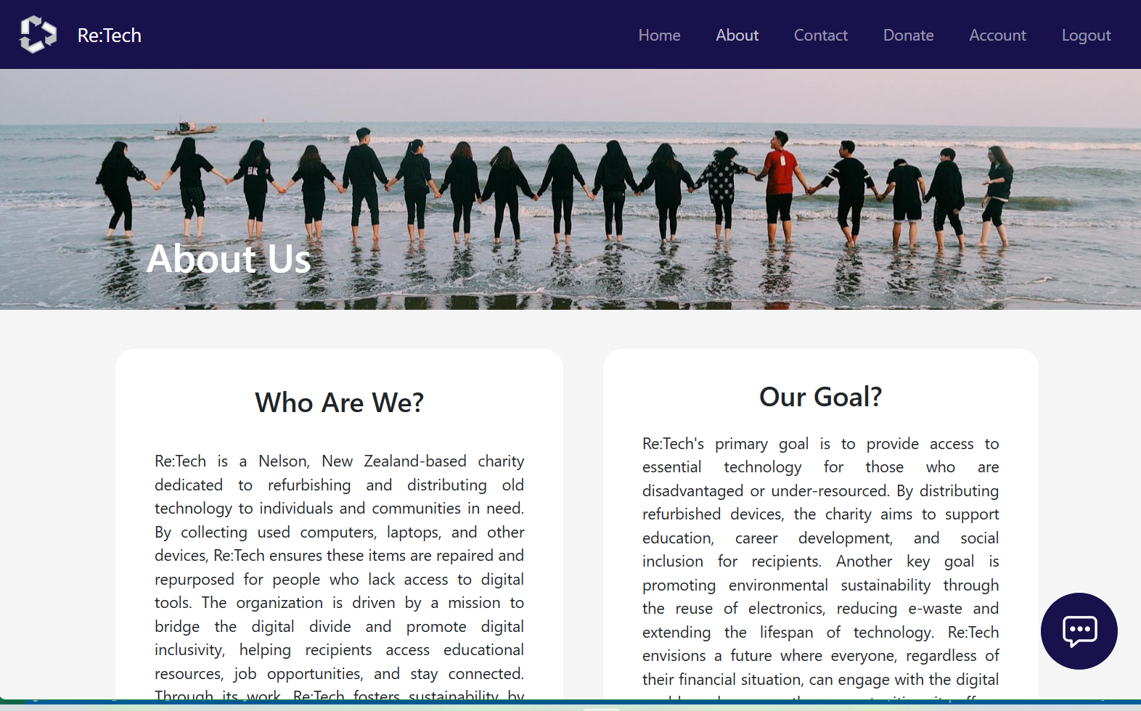

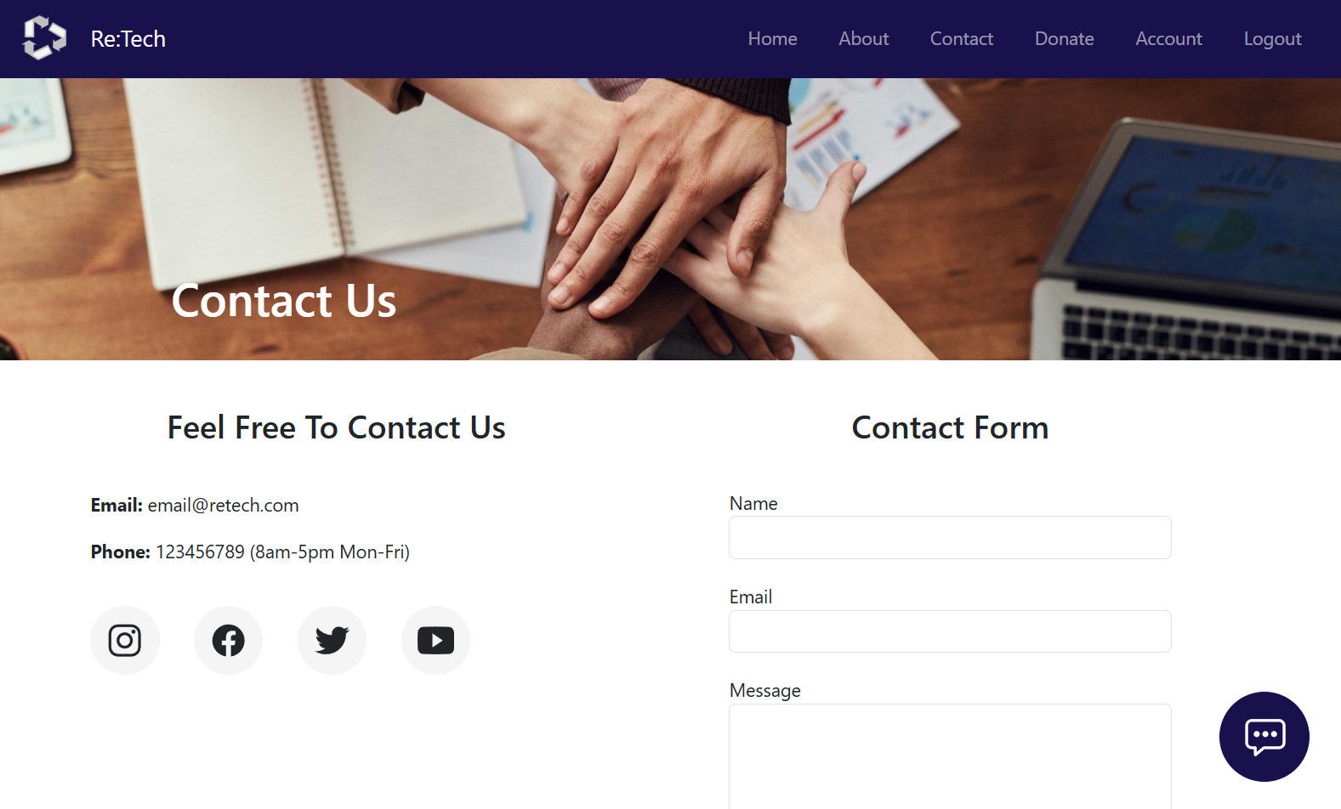

I have tested these features thoroughly through development and have fixed any identified errors. They should be working correctly.

**Critique**

I think using CSS modules was the best approach for styling. At the scale of my application, a single global stylesheet like I started with in the prototype would have been extremely long and convoluted, which is not a good approach. A global stylesheet does work well for holding a few styles used across many components and top app-level styles however, so I think a combination is the best approach.

Inline styling is another common approach, often using libraries like Tailwind, however I do not like this approach as it convolutes the HTML/JSX, making it harder to build components and pages. I could have used individual traditional CSS files for each component like I normally would, however I thought that CSS modules would be better. Modules allow for locally scoped class names. While this requires slightly more set up, it prevents class conflicts, which is especially useful for medium to large scale projects like this one.

I believe flexbox as the best general approach for layouts, as compared to other options like static layouts or grids, as it is very simple to set up, and naturally adds flexibility and responsiveness. While I have not made my design fully responsive, by using flexbox, it is already semi-responsive, which makes building a fully responsive design much easier and quicker.

### Token Transactions

*The system provides an interface that the members can use to accept a token in a transaction.*

From my original prototype, I already had a simple shop where beneficiaries could purchase items. This works by using a frontend service to collect all of the items in the database and return them as the content for displaying when the page is loaded. This content is mapped to item cards, which displays different properties from each item object.

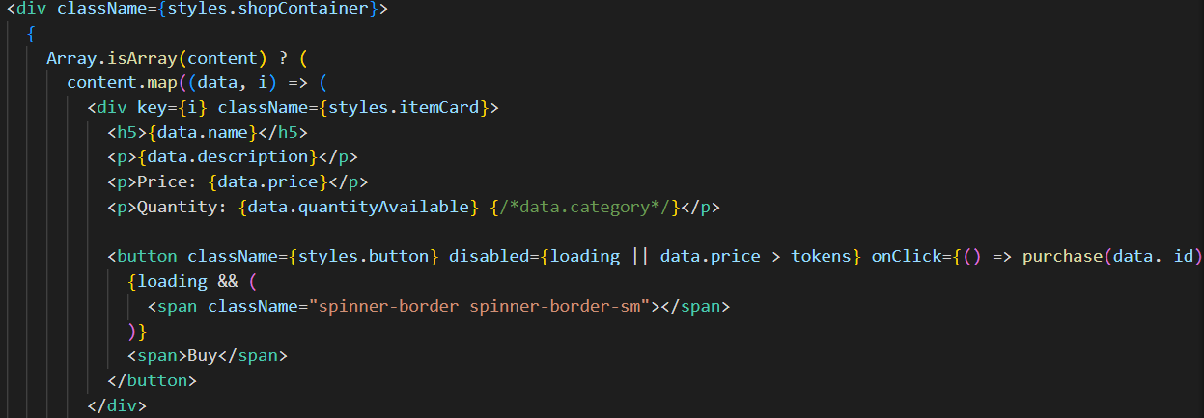

When the purchase button is clicked on an item, all buttons are disabled to reduce errors, and the shop service sends an item purchase request to the backend. The backend controller performs a number of checks to ensure that the purchase is valid, including checking that the item does exist, there is at least one available, and the user has enough tokens. If these pass, the purchase is performed. The controller returns the user’s new token value and purchase list. The profile page is then loaded with the new information.

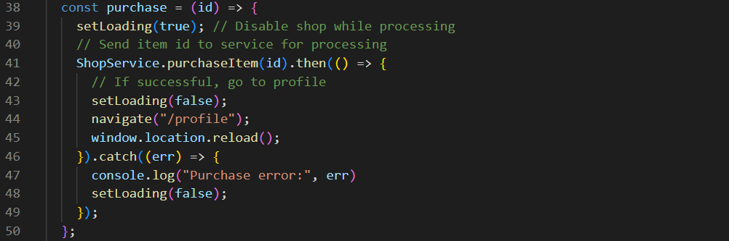

From here, I only had a to implement my design to make the shop visually appealing and easy to use, as well as add a few minor error handling additions. These included disabling the button if there were no items or the price was higher than the number of tokens the user had, so they could not make false purchases.

I have tested these features thoroughly through development and have fixed any identified errors. They should be working correctly.

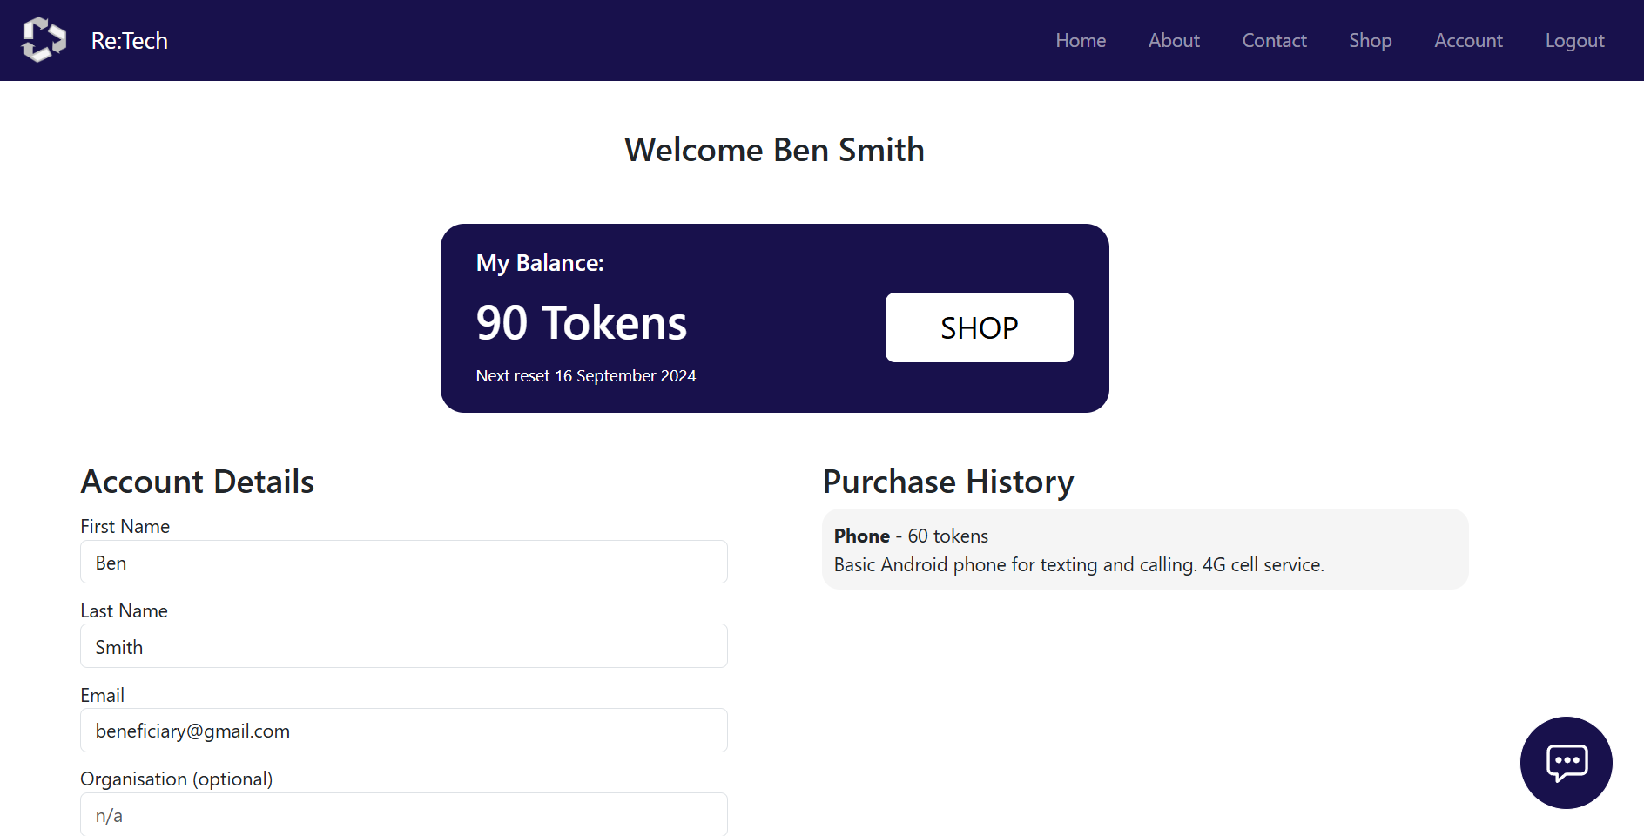

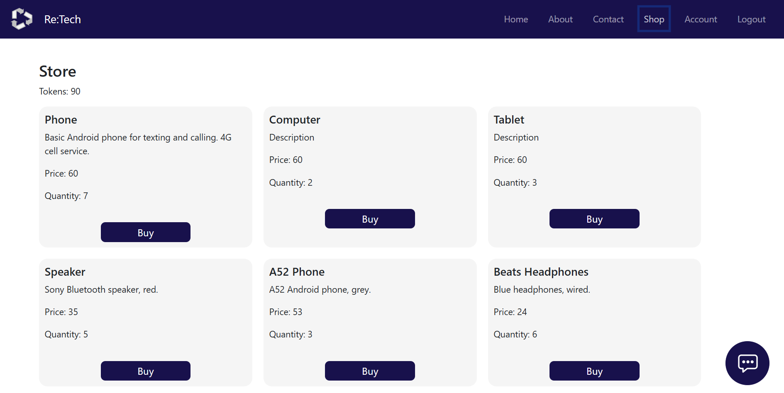

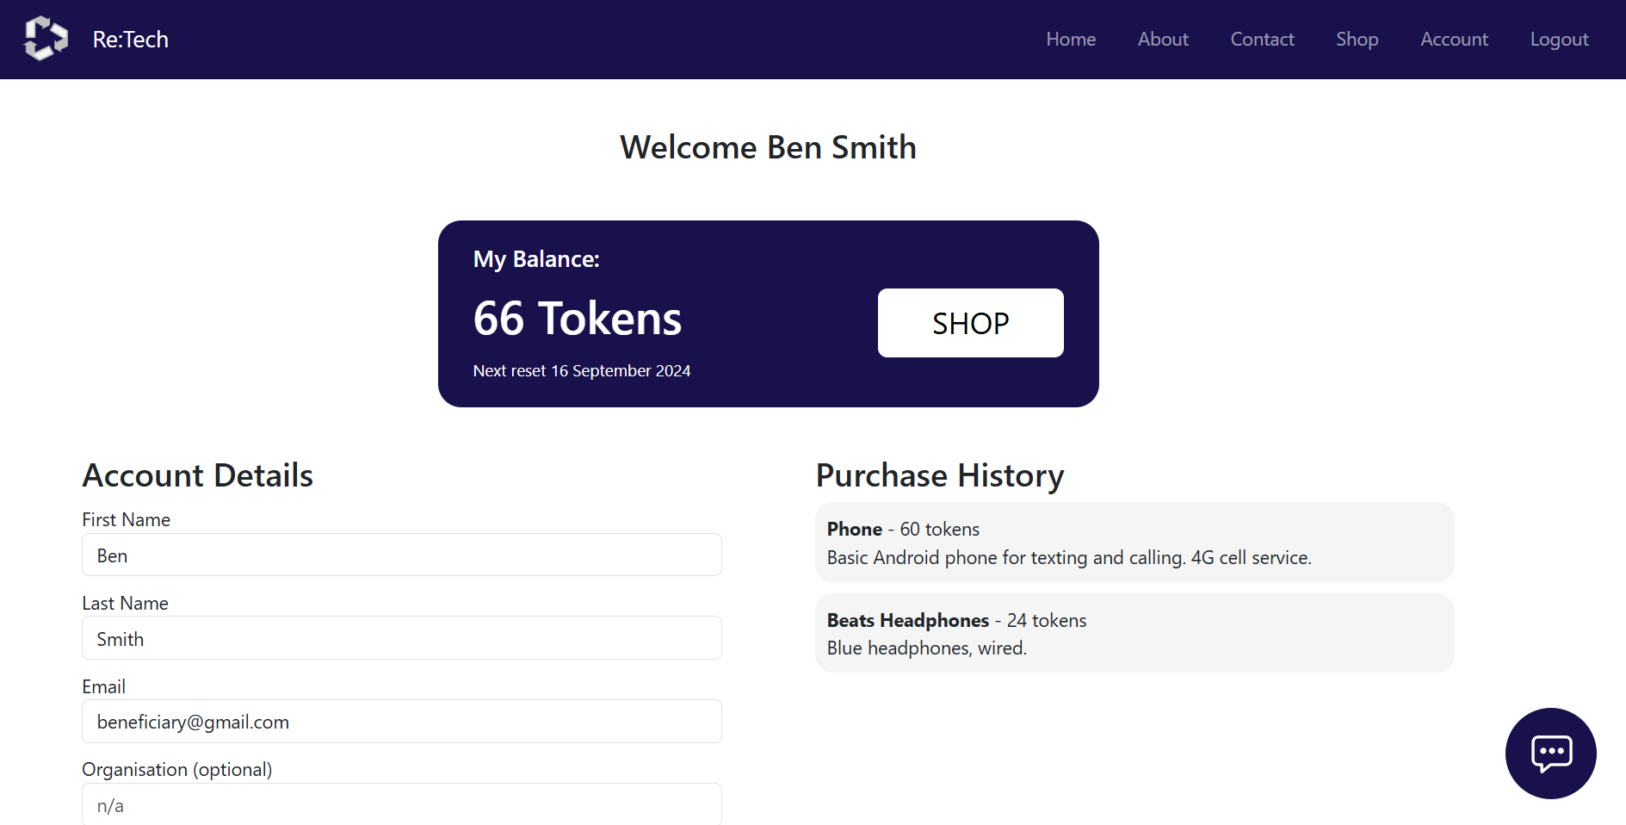

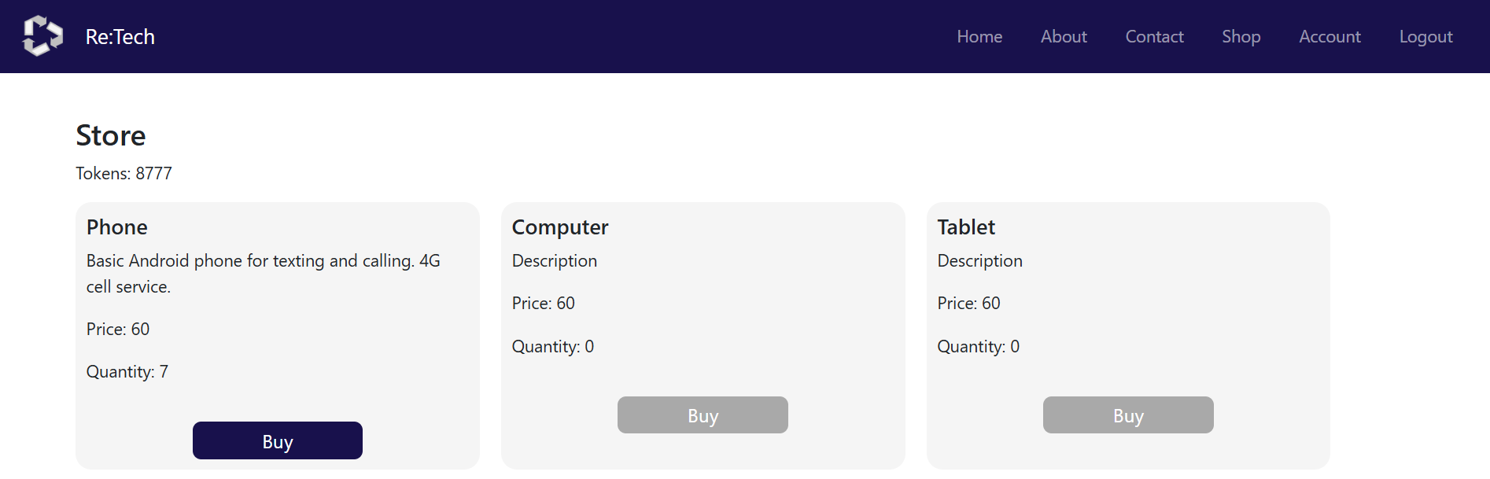

**Critique**

Mapping an array to HTML elements for a dynamic list is a common method to use in JavaScript. While this works well, I do like how Angular can import components easily into other components. This means that a shop component can be made, and item components can be imported and created automatically based on the item array. This helps separate out concerns between the shop and each item in terms of the HTML layout but also purchase handling, as the item component has the purchase function.

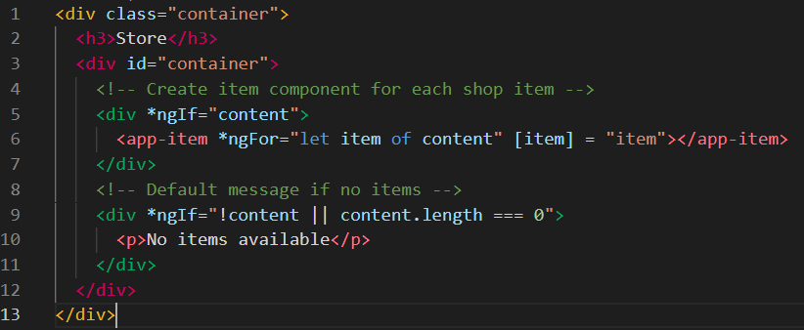

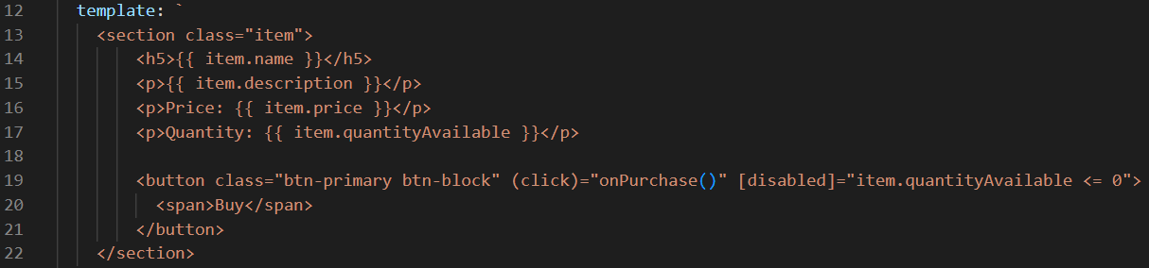

I think that this approach encourages slightly cleaner code, however when the rest of Angular is taken into account, I still think React is the better choice. React makes much more sense to me, leading to easier and faster development, and is more suited to a mid-scale web store, where Angular suits more enterprise level applications. For the scale of this application for creating item cards, mapping reduces complexity by not needing two components.

I made sure to include error handling and purchasing in the backend, as in the frontend it would be much easier to break and purchase items the user should not be able to. Server-side processing is much more secure, protecting the database.

### Server-Side Database

*Store and retrieve data from a server-side database (via API based on prototype undertaken in the DESIGN stage).*

During the implementation of my prototype, I setup most of my Mongo database and Mongoose connections in preparation for the final implementation. Originally, I looked at using a remote cloud-based cluster as my database, which I could connect to from anywhere. This however required me to sign into the online dashboard and update my access IP address every time, which was frustration and would have limitations for marking the project. Instead, I switched to hosting a database locally on my laptop. Once setup, this would connect immediately.

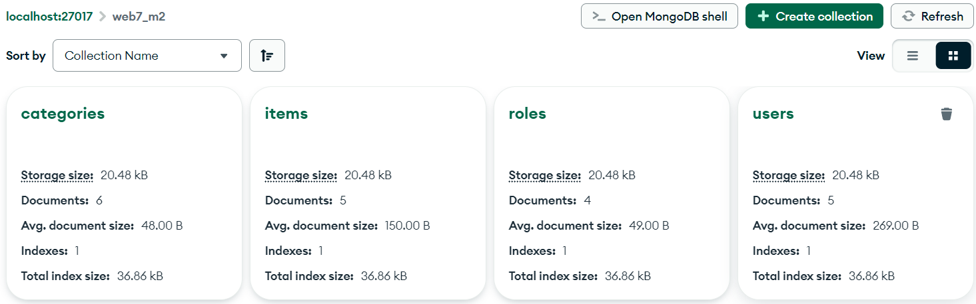

To access the Mongo database from my backend, I used Mongoose. This allowed me to construct scheme that represented the different data structures in the database. Below shows the item object structure and the properties it takes. Some properties link to other objects in the database (in this case category does), which forms a relationship between the two objects.

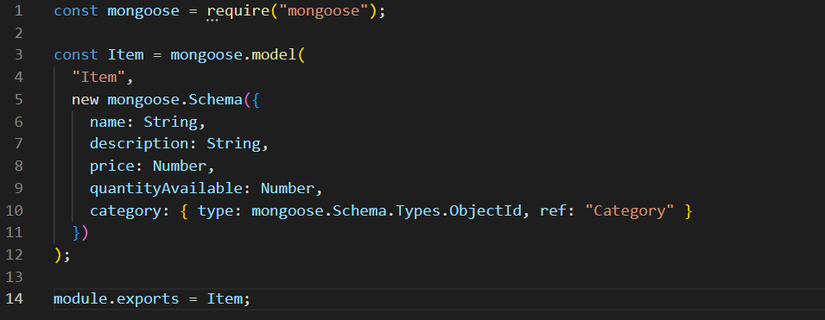

To allow the database to be easily setup on new machines, I created a setup script that creates the necessary collections and populates them with data if they don’t exist. This meant that the web application could be hosted locally on any other device.

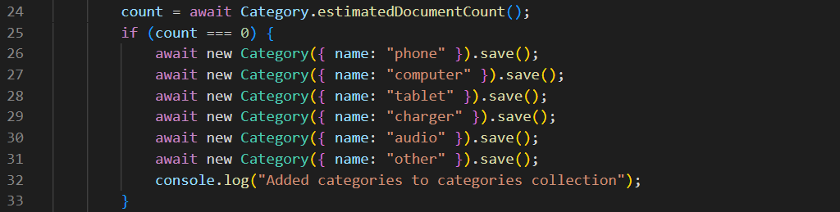

By importing the models into my backend controllers, I could then use Mongoose’s commands to access and manipulate items in the database, such as finding if an item exists for purchase or updating user’s details.

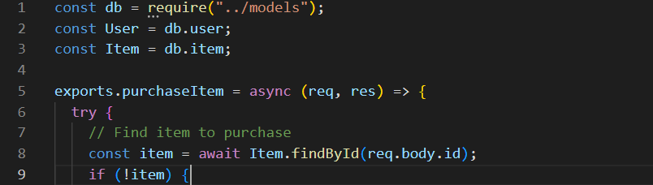



The database was already mostly setup from the prototype, so I only had to add a few missing fields to some models, and build more controllers that interfaced with the database to add more functionality, covered in the above sections.

I have tested these features thoroughly through development and have fixed any identified errors. They should be working correctly.

**Critique**

For a live web application, a cloud-based cluster would likely be a better choice. This would provide easy scalability, built-in security from Mongo, and access from any location. This would cost significantly more than hosting a small local database, however. For the purposes of this assignment, a locally hosted database is much easier to use and gives better accessibility for testing by different people. Scalability is not a concern and there is no budget, so local host was the better choice.

I selected MongoDB over relational databases like MySQL, SQL Server or PostgreSQL. All of these are strong and capable services with their own strengths and suitability’s. I decided to go with Mongo as I have the most experience with it in web development. For this demonstration, I was not concerned with high integrity of data or high performance, but ease of implementation was my main priority. In a production environment, integrity of data and high performance to handle thousands of request correctly and secure is vital, so likely a database like PostgreSQL would be a more suitable choice, but I think Mongo was fine for this assignment. I also didn’t have many relationships between items and no complex queries, so a NoSQL database was fine.

## Emerging Technology

### Research & Libraries

Emerging technology is a term used to describe new technologies, or existing technology that have recently had a significant breakthrough, that are creating or expecting to create fundamental impacts on society and the economy. There is no set timeline for what technologies count, but typically these are technologies that will each a plateau of productivity and user-integration in 5 to 15 years. Many common examples of modern emerging technologies are artificial intelligence (AI), virtual reality (VR), and the Internet of Things (IoT) (Digital Upskill, 2021; Winston & Strawn LLP, n.d.).

As emerging technologies are developed and enter the public sphere, their exposure and use-cases drastically increase. Enthusiastic developers and forefront businesses delve into these new technologies, looking for ways to implement them into existing tools and services, into new ideas that are now possible, and for new ventures to grows, expand and generate profit. These develops and businesses often develop new extensions or interfaces for emerging technologies for easier use or to expand their capabilities and compatibility with other technologies.

My emerging technology of choice is artificial intelligence (AI). As AI, specifically large-language models (LLM), were developed by large companies such as Google and OpenAI, these companies have been releasing public and paid API access to their models.

Ollama, a powerful open-source project for running LLMs locally, was recently founded with the aim of empowering users to explore and develop with AI without the needs for extensive technical expertise, or reliance on paid large-company APIs (1kg, 2024). Ollama is the tool that I have implemented into my project. Ollama provides command line and API interfaces to interact with local LLMs, as well as providing a huge library of models to select. By sending API requests to a running model, I can request responses to be generated, then handle these outputs in my backend, before sending the message to the frontend for display.

First, I built the chat interface based on a react chatbot interface I found on Codepen. With some fixes and improvements, I had a chatbot icon that hovered in the bottom corner of the screen at all times, that would open up into a chat interface. Next, I wanted to build the backend service which would handle API requests and interact with Ollama. I constructed the routes and backend controllers for handling the request. I wanted to ensure that I could successfully interact with Ollama, so I tested the API through Thunderclient first until it worked. I was then able to connect the backend with the frontend with a service, so messages could be inputted, responses generated, then displayed back in the chat.

Originally, I planned to use Ollama-JS, an alternative version of Ollama for JavaScript environments, however I ran into many performance issues (it was many times slower) and it provided less options which I needed. Instead of training my own model for the website, I decided it would be much easier and simpler to just pre-prompt the chatbot when it was first loaded with information about my charity to give it the required context, then feed in requests as normal. However, I found out that as LLMs are stateless, they retain no memory of previous messages, so it was not able to answer questions about the charity. After some research I discovered how LLMs use context, a collection of tokens outputted from the previous message to provide the contextual understanding to continue a conversation (Talamadupula, 2023). For some unknown reason, Ollama-JS handled the context internally but did not return it to the user, so I was not able to implement context handling. I instead had to switch to Ollama and use an API request with fetch to interact with the model. This allowed me to store the context from the pre-prompt to be passed back as context, which gave me perfect answers and also performed significantly faster to generate responses (20-50s -> 10-20s). From my understanding, Ollama-JS worked as a wrapper for Ollama for easier use in JavaScript environments, so I see no reason for such a significant performance decrease.

I started by storing just the context from the pre-prompt message, as updating the context could cause the bot to go “off-track” and forget old information, however once I had generated this once, the token context generated would be very similar each time, so I decided to store this in a config file. This saved 10-30 seconds starting and pre-prompting the LLM each time before messages could be send, now being instantaneous.

Response times a are much faster than before, however they do still vary. I am unsure why this is, but it is likely to do with the context and request provided causing longer generated for some messages.

### Implementation & testing

The chatbot code is in the following locations:

* Frontend/src/App.js: implements the chat interface into the entire app. Handles inputs and displaying responses.
* Frontend/src/services/chat.service.js: handles sending API requests to the backend
* Backend/app/routes/chat.routes.js: routes for the chat API.
* Backend/app/config/chat.config.js: stores the pre-prompt message and starting saved context.
* Backend/app/chat.controller.js: handles chat API request. Calls the backend Ollama service to generate responses.
* Backend/app/services/ollama.service.js: returns a fetch request promise to Ollama with the context and message.

This chatbot serves as an interface for users to find information in a more efficient manner and find clarification on specific questions easier than just browsing or searching the website. This will give the users a better experience and meet their needs better, while also reducing the user support and general enquiries through call or message that an office person would need to handle.

The chatbot icon always sits at the bottom right of the page, accessible from any screen.

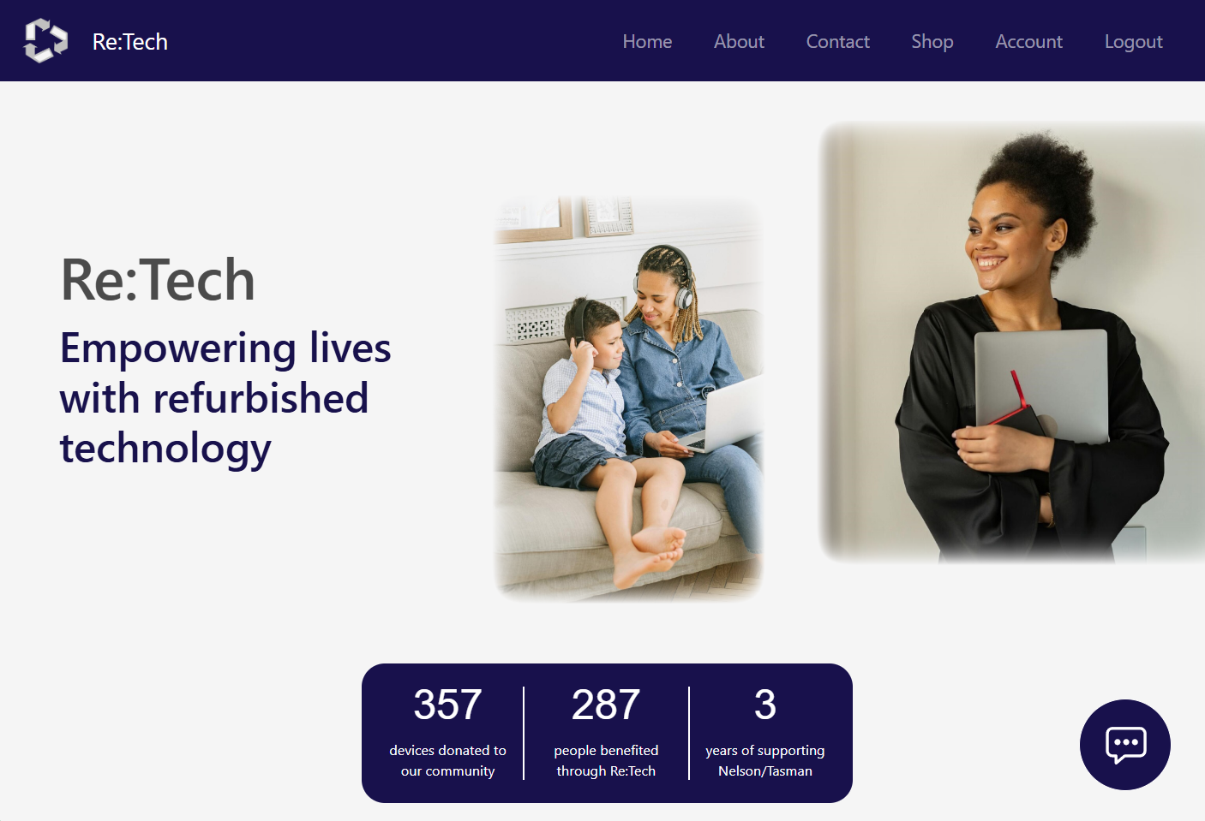

Messages can take some time to generate, so a message temporarily displayed showing that a message is being generated.

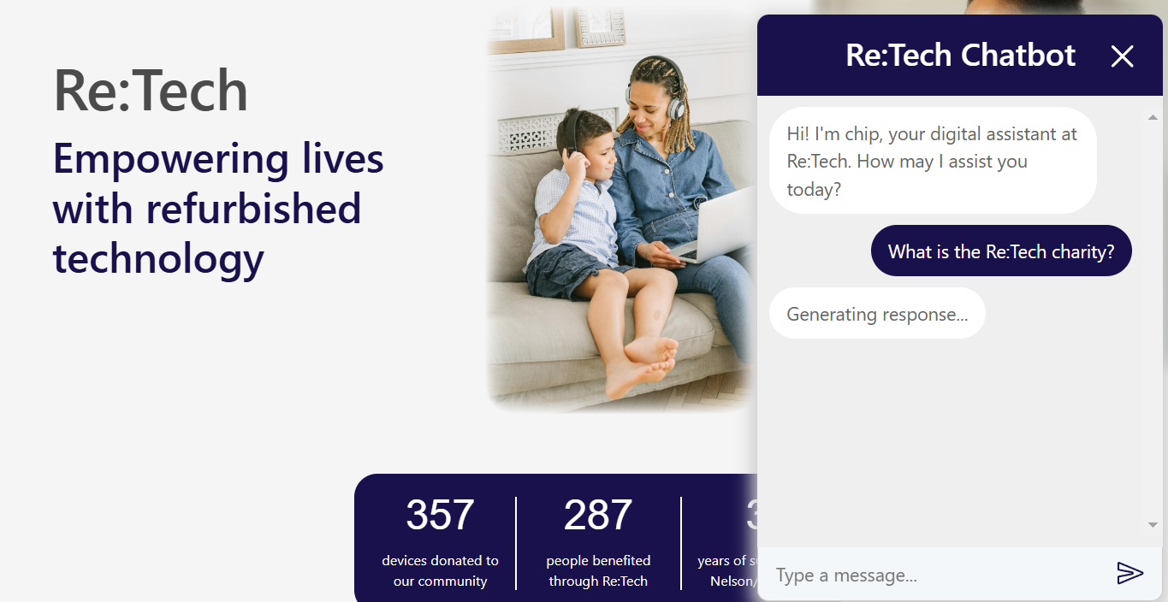

The chatbot aims to provide concise, helpful messages in response to the users inputs.

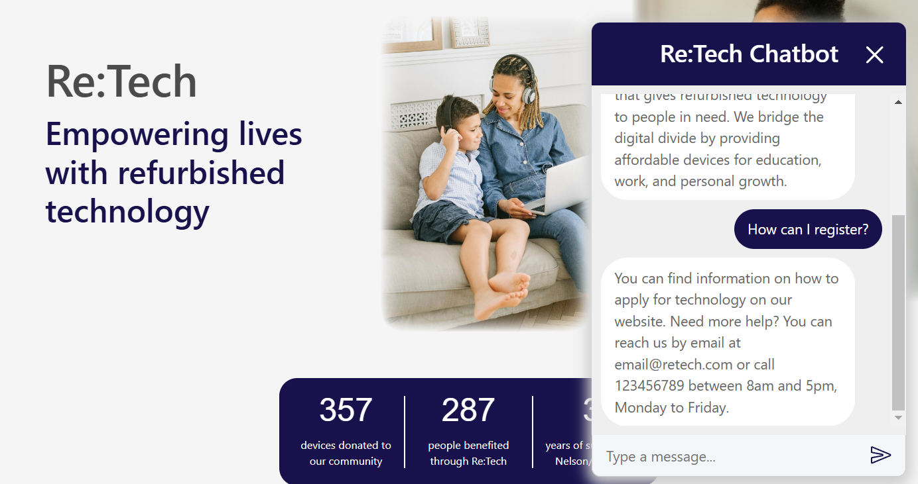

Please note: sometimes message generation can take a long time, and varies significantly. For example, the first message in this demonstration took 52 seconds, while the second message took 12 seconds to generate. Smaller models may improve performance, however this is primarily a hardware limitation. LLMs require a lot of processing power and are not designed for high performance work on a laptop. Realistically, if this website has to go live, the LLM would be hosted on a much more powerful machine capable of faster times or using a paid cloud API.

## Links

**DevOps:** <https://dev.azure.com/Jayden-Houghton/WEB701%20Charity%20Website>

Note: staff and admin features were excluded as out of scope for this project

**GitHub:** https://github.com/Jayden-Htn/WEB701_Project

# References

1kg. (2024, May 10). *Ollama : What is Ollama?* Retrieved from Medium: https://medium.com/@1kg/ollama-what-is-ollama-9f73f3eafa8b

Angular. (2023, July 29). *Angular components overview*. Retrieved from Angular v17: https://v17.angular.io/guide/component-overview

Angular. (n.d.). *New*. Retrieved from Angular Dev: https://angular.dev/cli/new

Angular. (n.d.). *Set up testing*. Retrieved from Angular dev: https://angular.dev/guide/testing

Attard, S. (2023, May 9). *How will AI transform the way we interact with software, the web and each other?* Retrieved from Medium: https://medium.com/@simon_attard/how-will-ai-transform-the-way-we-interact-with-software-the-web-and-with-each-other-85921cf181a2

Awan, A. A. (2024, May 9). *Run LLMs Locally: 7 Simple Methods*. Retrieved from DataCamp: https://www.datacamp.com/tutorial/run-llms-locally-tutorial

Chatterjee, S. (2023, September 1). *Web Frameworks: All You Should Know About*. Retrieved from BrowserStack: https://www.browserstack.com/guide/web-development-frameworks

Cloudflare. (n.d.). *What is a large language model (LLM)?* Retrieved from https://www.cloudflare.com/en-gb/learning/ai/what-is-large-language-model/

Digital Upskill. (2021, March 11). *What are emerging technologies and why are they relevant?* Retrieved from https://www.digitalskillup.eu/articles/what-are-emerging-technologies/

Ditgital Wings. (n.d.). Retrieved from https://www.digitalwings.nz/

Fernandez, T. (2024, June 18). *6 Ways For Running A Local LLM (how to use HuggingFace)*. Retrieved from Semaphore: https://semaphoreci.com/blog/local-llm

Goodwin, D. (2024, May 24). *Google AI Overviews under fire for giving dangerous and wrong answers*. Retrieved from Search Engine Land: https://searchengineland.com/google-ai-overview-fails-442575

Google. (2024, August 15). *AI Overviews and your website*. Retrieved from Google Search Central: https://developers.google.com/search/docs/appearance/ai-overviews

Innocent, C. (2023, November 14). *Best 19 React UI Component Libraries of 2024*. Retrieved from Prismic: https://prismic.io/blog/react-component-libraries

Machlis, S. (2024, April 25). *5 easy ways to run an LLM locally*. Retrieved from InfoWorld: https://www.infoworld.com/article/2338922/5-easy-ways-to-run-an-llm-locally.html

Matéu.sh. (2024, June 5). *What is the Virtual DOM in React?* Retrieved from FreeCodeCamp: https://www.freecodecamp.org/news/what-is-the-virtual-dom-in-react/

RE:MOBILE. (n.d.). Retrieved from https://remobile.org.nz/

Recycle A Device. (n.d.). Retrieved from https://www.recycleadevice.nz/

RNZ. (2024, September 11). *Government to launch AI chatbot called Gov-GPT*. Retrieved from Stuff: https://www.stuff.co.nz/nz-news/350411368/government-launch-ai-chatbot-called-gov-gpt

Sencha. (2024, July 16). *Web Application Framework – A Comprehensive Guide*. Retrieved from https://www.sencha.com/blog/a-comprehensive-guide-to-web-application-frameworks/

Sheldon, R. (n.d.). *web development framework (WDF)*. Retrieved from TechTarget: https://www.techtarget.com/searchcontentmanagement/definition/web-development-framework-WDF

Tableau. (n.d.). *What is the history of artificial intelligence (AI)?* Retrieved from https://www.tableau.com/data-insights/ai/history

Talamadupula, K. (2023, 12 21). *Guide to Context in LLMs.* Retrieved from Symbl.ai: https://symbl.ai/developers/blog/guide-to-context-in-llms/

TechCharities. (n.d.). Retrieved from https://techcharities.org/

Winston & Strawn LLP. (n.d.). *What Is Emerging Technology?* Retrieved from https://www.winston.com/en/legal-glossary/emerging-technology

World Computer Exchange. (n.d.). Retrieved from https://worldcomputerexchange.org/